EVIDENCING THE

OUTSOURCING OF

SOCIAL CARE PROVISION

IN ENGLAND

**Final Project Report**

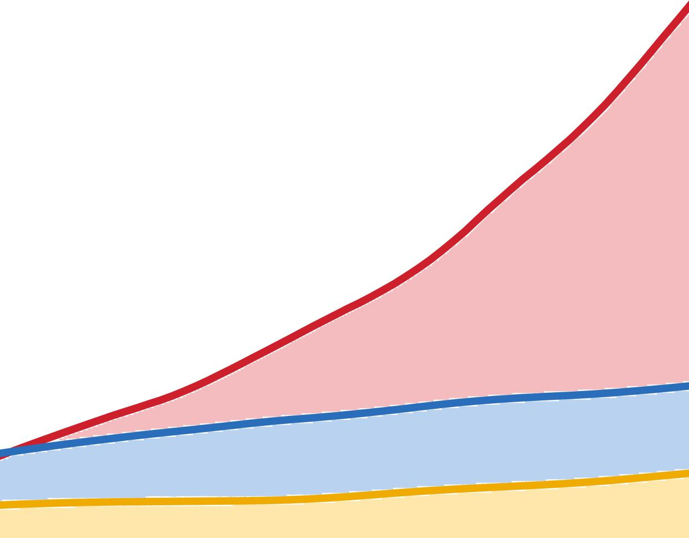

Anders Bach-Mortensen, Benjamin Goodair,  
Michelle Degli Esposti, Christine Corlet Walker,  
Jane Barlow.

# Executive summary

Social care services for children and adults in England have been increasingly outsourced to private (for-profit and third sector) providers over the last 30 years. However, the extent and impact of this marketisation are unclear, even to regulators and commissioners tasked with ensuring sufficient and quality provision. This lack of evidence has been cited as a major barrier to meaningful regulation and reform efforts aimed at addressing the perpetual crises facing both adult and children's social care sectors in England.

This Nuffield Foundation funded project aimed at overcoming these knowledge gaps by creating a comprehensive, longitudinal data resource on outsourcing trends and their associations with key outcomes in adult and children's social care provision across England. By harmonising fragmented publicly available administrative data from multiple sources, the report provides unprecedented insights into three areas:

1. The degree to which adult and children's social care services have been outsourced to private sector providers over time.
2. Differences in quality outcomes between public, for-profit and third sector social care providers as measured by regulator inspection ratings and enforcement actions.
3. Equity impacts of outsourcing on accessibility and quality by geographical area.

Provisional analysis of the data resource reveals that outsourcing of residential services like care homes and children's homes to private providers, especially for-profit companies, has increased dramatically over the last 20 years in both sectors. For adult social care, public provision has virtually disappeared, with 97% of residential services now outsourced. In children's social care, over 80% of children's homes are operated by for-profit companies, up over 20 percentage points since 2010.

Despite the growth of private provision, the inspection ratings from regulators consistently show that publicly-operated and third sector adult care homes and children's homes outperform those run by for-profit providers on measures of quality. Involuntary closures and cancellations enforced by CQC and Ofsted are also concentrated among for-profit providers.

The data further suggest outsourcing has not enabled the survival of the highest quality services. Instead, for-profit adult care homes appear increasingly focused on self-funded residents in affluent areas, potentially leaving those in deprived localities with fewer options. In children's care, for-profit children’s homes concentrate in disadvantaged areas with lower property prices, exacerbating existing issues such as children being placed far outside their local authority areas.

Overall, the findings reveal a paradox – despite private for-profit provision consistently underperforming public and third sector operators on inspection metrics, outsourcing to for-profit providers has accelerated, especially in residential care settings such as nursing homes and children's homes. Moreover, the evidence raises concerns about whether the current outsourcing landscape is achieving sufficient quality, equity, and access for adult and children's social care across England.

The findings presented in this report highlight the value of using existing data to inform research and policy decisions related to the ongoing "care crisis" in both sectors. However, significant data gaps remain as regards key issues such as provider profits, resident characteristics, and contract details between commissioners and providers. Addressing these gaps in the evidence is crucial for effective regulation and reform.

**Key findings**

1. Adult and children’s social care commissioning are increasingly guided by similar principles of ‘mixed markets’.
2. Outsourcing to private for-profit providers has consistently increased in adult and children’s social care services since 2010.
3. Public provision has become displaced and is either substantially reduced or virtually eliminated for residential care settings.
4. Outsourcing has primarily benefited for-profit providers and private third sector provision has failed to grow in adult and children’s social care.
5. Despite the growth of private provision, inspection ratings from regulators consistently show that publicly-operated and third sector adult care homes and children's homes outperform those run by for-profit providers.
6. Involuntary closures and enforcement actions by regulators are concentrated among for-profit operators in both sectors.
7. Outsourcing is associated with inequalities in provision as for-profit adult care homes attract self-funded residents in affluent areas, potentially leaving those in deprived localities with fewer options and for-profit children's homes are concentrating in disadvantaged areas with lower property prices, exacerbating issues like children being placed far from their home areas.
8. Significant data gaps remain with regard to provider profits, detailed resident characteristics, and specifics of contracts between commissioners and providers, hindering effective regulation and reform efforts.
9. The data resource will be publicly released to enable further analysis and research. This lays the empirical foundation to guide meaningful reform efforts and identify remaining data gaps that must be filled to effectively regulate and improve both sectors.

# Table of contents

**Glossary and abbreviations 4**

**List of Figures and tables 5**

**Introduction and background 6**

**Policy and regulation context 7**

How did adult and children’ social care become outsourced? 7

Why harmonise data on adult and children’s social care? 9

**Objectives 9**

**Methodology 10**

Data harmonisation 10

**Results 12**

Data resource 12

Analysis 14

**Discussion 29**

The extent of outsourcing: the end of public provision? 30

The type of outsourcing: where is the third sector? 30

The location of outsourcing: are for-profit providers targeting deprived or affluent areas? 31

The for-profit paradox 31

**Conclusion 3****3**

**Project Outputs 3****4**

**References 36**

**Acknowledgements 39**

# Glossary and abbreviations

**For-profit sector:** Private for-profit providers of social care. This includes individually-owned providers, partnerships, registered companies, and private-equity owned providers.

**Third sector:** Private not-for-profit providers of social care. These providers are usually registered as charities.

**Public sector:** Care providers operated and organised by government bodies and employees. These providers are usually operated by the local authority.

**Adult social care:** “Social care includes support in people’s own homes (home care or ‘domiciliary care’); support in day centres; care provided by care homes and nursing homes (‘residential care’); ‘reablement’ services to help people regain independence; providing aids and adaptations for people’s homes; providing information and advice; and providing support for family carers.” [(The King’s Fund 2023)](https://www.zotero.org/google-docs/?SSuDU8). In this report we use different measures, but our provider level analysis is focused on residential care homes.

**Children’s social care:** “Children’s social care refers to all forms of personal care for children and young people who need extra support.”, which “[...] can range from low level support, such as personal home visits to help keep a young person active and involved in the community. Or it can be higher level. In some cases a young person might need to be taken into care.” [(The Children’s Society 2022)](https://www.zotero.org/google-docs/?BeVR2l). In this report we use different measures, but our provider level analysis is focused on children’s homes.

**Outsourcing:** Private (third sector and for-profit) providers “[…] delivering services to the government or the public after a process of competitive tendering.” [(Sasse et al. 2019)](https://www.zotero.org/google-docs/?NlBndo)

**Market stewardship**: “the long-term oversight of market mechanisms, as well as the commissioning process” [(Gash et al. 2013)](https://www.zotero.org/google-docs/?pmnYtb)

**DfE:** Department for Education

**CMA:** Competition and Markets Authority

**LA:** Local Authority

# List of Figures and tables

**Tables**

* **Table 1:** Key databases in data resource
* **Table 2:** Cancellation and voluntary resignations of children’s homes, 2014-2023.

**Figures**

* **Figure 1:** Data resource structure
* **Figure 2:** Local Authority expenditure on outsourced Adult Social Care
* **Figure 3:** Local Authority expenditure on direct payments
* **Figure 4:** Local Authority residential placements in outsourced settings
* **Figure 5:** Growth in the number of for-profit adult care homes and beds
* **Figure 6:** Local Authority expenditure on outsourced children’s social care, 2010-2023
* **Figure 7:** Outsourced expenditure for children’s social care broken down by service type, 2010-2023
* **Figure 8:** Changes in the percentage of outsourced placements by year and local authority
* **Figure 9:** Homes rated Outstanding or Good by ownership status 2014-2023, England.
* **Figure 10:** Voluntary and involuntary closures by provider and registered beds, 2011-2023.
* **Figure 11:** Children’s Homes rated ‘Good’ or ‘Outstanding’ by ownership status, 2015-2023.
* **Figure 12.** Proportion of monitoring inspections by ownership in children’s homes, 2015-2023
* **Figure 13:** Distribution of inspection outcomes for active and closed homes across ownership and IDAOPI deciles (1=most deprived).
* **Figure 14:** Resident mix by ownership and IDAOPI deciles
* **Figure 15:** Funding status by ownership and quality.
* **Figure 16:** Placement outcomes by year and local authority, 2011-2023
* **Figure 17:** Net change in number of children’s homes and area deprivation, 2016-2023

# Introduction and background

**Why is there a need for harmonised data on the outsourcing of social care?**

The social care sector in England has adopted a commissioning structure that promotes and facilitates the outsourcing (defined as the private sector delivery of public services following a tender process) of social care provision to private (for-profit and third sector) providers. Proponents of outsourcing argue that it counteracts the inefficiency of state monopolies by allowing open competition in care service provisions. However, the shift towards outsourcing social care to private (most of which are for-profit) providers has been accompanied by significant austerity measures raising questions around the underlying motive for outsourcing social care provision (e.g., [(Glasby et al. 2020; Webb 2021)](https://www.zotero.org/google-docs/?G7C0sD)). A growing body of research shows that for-profit providers of adult social care perform less well than third sector and public providers (e.g., [(Amirkhanyan et al. 2018; A. M. Bach-Mortensen, Goodair, and Barlow 2022; Barron and West 2017)](https://www.zotero.org/google-docs/?Vt1Ya3)), raising questions regarding the appropriateness of outsourcing social care services to the private for-profit sector.

The promise of reduced costs and improved services makes outsourcing an appealing strategy for commissioners to cope with reduced funding [(A. Bach-Mortensen, Murray, et al. 2022; Gingrich 2011)](https://www.zotero.org/google-docs/?IUMFZy). However, to ensure that these conditions are met, market stewardship, defined as “*the long-term oversight of market mechanisms, as well as the commissioning process*” (Gash et al., 2013), is key. In England, local authorities (LAs) are responsible for overseeing the commissioning and provision of social care services, but it is known that social care spending and performance varies widely for different LAs, leading to “[…] *a postcode lottery in standards of provision*.” [(House of Lords Economic Affairs Committee 2019](https://www.zotero.org/google-docs/?LsXBtV)). Yet the need for these services has never been higher. The number of children in care is at an all-time high at 83,840 (March 2023), which is an increase of 30% since 2010 [(DfE 2023)](https://www.zotero.org/google-docs/?Lm6oT4). This is expected to go up in adult social care too: a 2021 National Audit Office (NAO) report projects that the number of people above 65 in need of social care will increase 57% (representing a 106% cost increase) by 2038 [(National Audit Office 2021)](https://www.zotero.org/google-docs/?AluG0a).

At the same time, both sectors are in perpetual crisis. In England, there is broad agreement that the adult and children’s social care sectors are struggling and underfunded. Various reports by the regulators (Ofsted and the Care Quality Commission), the Competition and Markets Authority [(CMA 2018, 2022)](https://www.zotero.org/google-docs/?aBDk3k), and numerous other sector reports have echoed concerns with regard to the critical state of care in both sectors [(Children’s Commissioner 2020; CQC 2023c; National Audit Office 2021; Ofsted 2021; UK Parliamentary Debate 2020)](https://www.zotero.org/google-docs/?BJUsiG). Despite differing challenges between children’s and adult’s social care, reports consistently highlight similar issues concerning decreased budgets, ineffective commissioning, and inadequate regulation.

The care crisis has been accompanied by outsourcing, but the connection between these two developments are unclear and heavily contested. What is not contested is that both sectors are increasingly outsourced, especially residential services, such as nursing homes and children’s homes. At aggregate level, adult social care has become almost entirely outsourced: more than 85% of care homes are for-profit, 12% third sector, and less than 3% are operated by LAs [(A. Bach-Mortensen, Goodair, and Degli Esposti 2024)](https://www.zotero.org/google-docs/?xqW40Y). Similarly, 80% of all children’s homes are for-profit. Outsourcing practices vary by local authority and regional levels, but it is largely unclear which LAs have opted to outsource their services and to what degree. Moreover, little is known about the ability of commissioners and regulators to oversee this development. In fact, the role of specific LA characteristics, such as population demographics, social care spending, area deprivation, and local politics in determining market and service outcomes is poorly understood.

This lack of evidence is often reported as a central barrier to regulation. For example, in the context of adult social care, a 2021 NAO report found that the Department of Health and Social Care “[…] *lacks visibility of the effectiveness of local authority commissioning.”* (National Audit Office 2021). For children’s social care, a 2019 Committee of Public Accounts concluded that the Department of Education “[…] *cannot explain why there is so much variation between local authorities in the activity and cost of children’s social care.“* [(Public Accounts Committee 2019)](https://www.zotero.org/google-docs/?BZhoFz). The absence of systematic, transparent, and comprehensive data on both children and adult social care poses important problems in terms of understanding and addressing the serious challenges facing these sectors.

Debates about the appropriateness and consequences of outsourcing for each sector, or how to best regulate adult and children’s social care provision, thus lack comprehensive data on outsourcing trends and provider characteristics.

This project aims to directly address this information barrier to meaningful regulation through the creation of a comprehensive, centralised, and longitudinal data resource of harmonised routinely collected data on providers (i.e., facilities registered with Ofsted and the Care Quality Commission (CQC)) and commissioners (Local Authorities) of social care services for children and adults in England.

# Policy and regulation context

## How did adult and children’ social care become outsourced?

Below we discuss the policy and regulatory context that have accompanied the outsourcing of adult and children’s social care. The regulation context varies by sector, and we will outline the legislation for adult and children’s social care separately. This work was based on a detailed analysis of policy intentions, which can be read in full here (link).

***Adult social care***

Adult social care in England has undergone a progressive privatisation through outsourcing since the enactment of Margaret Thatcher’s National Health Service and Community Care Act in 1990 [(Knapp, Hardy, and Forder 2001)](https://www.zotero.org/google-docs/?VoAPBK). The act had the effect of changing the role of local authorities from being primarily responsible for delivering adult social care, to gradually becoming responsible for coordinating and commissioning it from the private market (Barron & West, 2017; The King’s Fund, 2006). The act also embedded the concept of consumer choice, enabling individuals to choose which provider to receive care from. Additionally, there was a growing focus from the former Audit Commission on the value for money achieved through their commissioning practices[(The Health Foundation 2023)](https://www.zotero.org/google-docs/?UvrFDH). In the three decades following the Community Care Act 1990, the adult social care provisioning landscape changed dramatically.

The shift towards marketisation that began in the 1990s was based on two important assumptions; that it would improve consumer choice and deliver more efficient care services. These assumptions have then been re-embedded in more recent legislation, affirming the government’s commitment to marketisation and the ideas behind it. One of the major policy reforms of note within the adult social care sector since 2010 was the [Care Act 2014](https://www.legislation.gov.uk/ukpga/2014/23/part/1/crossheading/general-responsibilities-of-local-authorities/enacted), which explicitly states that the responsibilities of Local Authorities are to promote the “*efficient and effective operation of a market in services for meeting care and support needs*” [(Care Act](https://www.zotero.org/google-docs/?uILoeB); 2014; Part 1 Section 5(1)).

The intention of the Care Act 2014 was for outsourcing to improve the well-being of adults in care, promote user choice, and increase the quality of services (see appendix X for an elaboration of how the act promotes each policy intention). In doing so, it was intended to *“[...]dissolve the traditional boundaries that lie between the third sector, private organisations, local authorities and individuals*” [(HM Government 2012)](https://www.zotero.org/google-docs/?GDBYZT). However, rather than to create a ‘mixed market’ with ownership diversity, for-profit services have gradually continued to increase as public and third sector provision has effectively disappeared from the sector.

**Box 1. The resident mix in adult social care - why does funding status matter?**

|  |
| --- |
| In England, adult social care is operated in a two-tier system composed of self- and state-funded residents. Residents are eligible for state support if their savings do not exceed £23,250, or if they do not own their home – although these criteria are scheduled to change in October 2025 [(NHS 2022)](https://www.zotero.org/google-docs/?ivXKoB). Most care homes serve a mix of state- and self-funded residents, and less than 1.3% of all care homes only include self-funded residents [(ONS 2023)](https://www.zotero.org/google-docs/?Y5JuLJ). However, funding for state-residents is widely considered inadequate [(CMA 2018; Schlepper and Dodsworth 2023)](https://www.zotero.org/google-docs/?04hNuE), and the ability to attract self-funders has increasingly become financially imperative [(Henwood et al. 2022)](https://www.zotero.org/google-docs/?7IhWV2). This creates an incentive for providers to focus on access to self-funders rather than care needs, increasing the risk of unmet and under-met need for already vulnerable residents. In a 2023 report, the CQC itself has expressed concern that this may exacerbate existing inequalities: “As *adult social care places funded by a local authority are often less profitable, there is the risk that people who live in more deprived areas, and are more likely to receive local authority-funded care, may not be able to get the care they need*.” [(CQC 2023a)](https://www.zotero.org/google-docs/?bmM3IV). This highlights existing concerns of equitable service provision between affluent and poorer populations and areas. However, relatively little is known about the specific characteristics of self- versus state-funders, but there is a clear tendency that care homes operating in less deprived areas have a higher proportion of self-funders [(ONS 2023)](https://www.zotero.org/google-docs/?sZzm7i)*.*  Data on the population of self- and state-funders has historically been absent and poor. Recent work by the ONS has improved the data on this at Local authority level. However, it is unclear how funding status relates to outsourcing, area deprivation, and quality. This data has not previously been collected systematically, but since 2020, the Care Quality Commission has required this information from all registered providers via the Provider Information Return (PIR). In this report, we will report novel results that combine our data resource with anonymised data on funding status from the PIR. |

***Children’s social care***

Compared to adult social care, children’s social care has seen the largest changes in private provision since 2010, with children’s homes having largely transitioned to the for-profit sector. Historically, for-profit private sector outsourcing has been restricted to placements for looked-after-children, such as children’s homes and foster care. Since 2010, private sector delivery of these services has increased significantly, and is now the dominant provision type for residential and foster care.

An interesting way that the children's social care sector stands out from the adult and health care, is that the role of outsourcing is much vaguer in terms of the legislation. There have been no major legislative reforms to the procurement, licensing, or regulating of providers of children’s social care placements since the marketised system was largely established in 1989. This absence in terms of intentional reform relating to outsourcing was highlighted in the 2022 Competition and Market Authority’s (CMA) children’s social care market study, which found that competition through open tender does not appear to be the result of ‘deliberate policy choices’:

“[...]*the placements market as it operates today is not the result of deliberate policy choices by national governments on how children’s social care should be delivered, but rather a reaction by multiple local authorities, voluntary providers and private providers to a range of factors – including regulatory developments, financial constraints and reputational risk – that have played out over time*.” (CMA, 2022; 36)

This means that the transition to for-profit provision has happened without being subject to regular democratic accountability.

## Why harmonise data on adult *and* children’s social care?

There are important differences in the policy and regulatory context for the outsourcing of adult and children's social care. Yet, the sectors share three important trends: First, both sectors have experienced a significant increase in outsourcing, especially in the last decade. Second, the demand for adult and children’s social care has increased since 2010 [(CQC 2023c; DfE 2023)](https://www.zotero.org/google-docs/?bOObAx). Third, each sector operates under different commissioning structures and regulatory frameworks, making it valuable to examine the outsourcing trends and outcomes separately. Both sectors share meaningful similarities, given they both provide care to populations with the shared goal of safeguarding and enhancing the quality of life for service users.

Research conducted on siloed services will not enable a broad understanding of what an alternative policy and market stewardship environment might mean for outcomes. No research to date has analysed and compared trends in outsourcing and the changing provision landscape in both sectors. Our intention is that this data resource can directly address this and enable learning within and between both areas of care.

# Objectives

The extent and timing of the outsourcing of social care services has been difficult to evaluate, even to those in charge of ensuring the best outcomes for service users [(House of Lords Economic Affairs Committee 2019; Housing Communities and Local Government Committee 2019; National Audit Office 2021)](https://www.zotero.org/google-docs/?w7Mulj). Improvements in administrative and computational data science mean that it is now possible to trace shifting outsourcing and provision ownership patterns with unprecedented granularity.

The overall aim of this project is to address the current knowledge gap regarding the outsourcing of children’s and adult social care, and to map the uptake of outsourced adult and children’s social care services over time. By harmonising fragmented publicly available administrative data from multiple sources, the report provides unprecedented insights into the following three areas:

1. The degree to which adult and children's social care services have been outsourced to private sector providers over time.
2. Evidencing differences in quality outcomes between public, for-profit and third sector providers as measured by regulator inspection ratings and enforcement actions.
3. Equity impacts of outsourcing on accessibility and quality by geographical area

# Methodology

One of the most reported barriers to understanding and analysing the consequences of outsourcing social care services in England is the lack of comprehensive data. To address this knowledge gap, we created a centralised longitudinal data resource by harmonising publicly available administrative data from multiple sources on social care providers, commissioners, and service users.

## Data harmonisation

To enable improved documentation of outsourcing and its impacts, we developed a data resource, using publicly available central and local government data sources. Our focus was on databases with information related to the outsourcing of social care provision, including, but not limited to, provider information, expenditure, and inspection ratings. The full list of databases can be found in the appendix, and the key databases are shown in Table 1.

All publicly available provider and LA data was aggregated by the calendar year and matched according to the unique identifiers of the LA (using ONS ID codes) and care provider (using the Unique Reference Number for facilities registered with Ofsted and the Location ID for those registered with the CQC). All our data, processes and outputs are publicly available, reproducible from raw to final data, and are all published online. We include more details about the data harmonisation process in the supplementary appendix.

**Table 1:** Key databases in data resource

|  |  |  |  |  |
| --- | --- | --- | --- | --- |
| **Dataset** | **Source (availability)** | **Year** | **Example of key variables** | **Geographical level** |
| Local authority and children’s homes in England inspections and outcomes | Ofsted (publicly available) | 2014 - ongoing (yearly) | Ofsted inspection ratings (provider and local authorities); Provider ownership and characteristics; Inspection dates | Provider and local authority |
| Violated regulations and recommendations among children’s homes | Ofsted (received via data request) | 2014-2022 (at data manager discretion) | Number and type of violated recommendations and requirements | Provider |
| All children’s home closures | Ofsted (received via data request) | 2014 - March 2023 (at data manager discretion) | URN, resignation status, and closed date | Provider |
| Children looked after in England including adoptions (SSDA903) | Department for Education (publicly available) | 2011 - ongoing (yearly) | Children placed in private provision (%); Children placed in third sector provision (%); Placement stability and locality | Local Authority |
| S251 return - Children and Young People's Services (National, Regional, LA levels)' from 'LA and school expenditure | Department for Education (publicly available) | 2008 - ongoing (yearly) | Spend on private provision (total CLA, residential services, fostering services, adoption services) · Spend on LA provision · Spend on voluntary provision | Local Authority |
| CQC-registered care providers | Care Quality Commission (publicly available) | 2011 - ongoing (daily) | CQC inspection ratings; Provider ownership and characteristics; Inspection dates | Provider |
| Enforcement-related closures of CQC providers | Care Quality Commission (publicly available but received via data request) | 2011-2023 (at data manager discretion) | Enforcement-related closures | Provider |
| Provider information return | Care Quality Commission (received via data request) | 2020-2023 (at data manager discretion) | Funding status of residents; use of agency staff; staff qualifications; number of complaints; notifiable safety incidents; turnover rates | Provider - but anonymised |
| Adult Social Care Finance Return | NHS digital (publicly available) | 2015-2023 (yearly) | Expenditure on social care, by service type, user need, sector | Local authority |
| Short and Long Term Care Collection | NHS Digital (publicly available) | 2015-2023 (yearly) | Number of claims, and users of care, by service type, user need and sector | Local Authority |
| Personal Social Services: Expenditure and Unit Costs | NHS Digital (publicly available) | 2001-2014 (yearly) | Expenditure and number of users of adult social care, by service type, user need and sector | Local Authority |

**Coding ownership and outsourcing**

When interpreting the results, it is important to note the difference between *ownership* and *outsourcing*. Provider ownership refers to the ownership structure of social care providers. This is traditionally categorised in three groups: for-profit, third sector, and local authority provision, but other categorisations include social enterprises, private-equity facilities, and multi-location provider chains. Outsourcing refers to the expenditure used on or the number of providers/places in the private sector, including both third sector and for-profit provision. In the report, we have operationalised each as follows:

***Provider ownership****:* We coded provider ownership by categorising all registered charities and charitable companies as ‘third sector’, and all private companies, partnerships, and individual providers without a charity number as ‘for-profit’. All council, NHS, and municipality care homes were coded as ‘public’. For adult social care, we also identified for-profit private homes operated by individuals and partnerships versus private companies. Additional categorisations are available in our dataset but are not included in this report.

***Outsourcing****:* We generally report on three measures of outsourcing: expenditure, number of private providers, and number of places in private provision. Some measures will include all private providers (ie., both for-profit and third sector), but we distinguish between these categories when the data allows us to.

# Results

## Data resource

Our data resource is an aggregation of over 120 million observations measuring the characteristics, experiences, services, and outcomes for children in care. The number of records for adults receiving social care services in England is similarly large, containing £260bn of expenditure linked to outsourced or publicly owned services. The data resource is a carefully cleaned and standardised compilation of all currently available variables related to outsourcing, aggregated as far back as is available – usually to 2010/11, although some variables can be traced back to 2001. This provides (at least) 13 years of data with unprecedented temporal and geographical granularity to analyse the trends and variation in the outsourcing of adult and children's social care.

In terms of inspection ratings, our final dataset for adult social care included a total of 65,726 CQC inspection reports of residential social care providers from 2014-2023. We included 29,548 unique location IDs, which translates into 23,022 unique care homes, when accounting for provider takeovers and address changes. For children’s homes, our final inspection dataset includes 27,449 Ofsted inspections from 2014 to 2023, covering 3,856 unique locations. The inspection data contains the provider’s allocated ratings (broken down by the inspection domains, such as overall, leadership, safeguarding - see appendix page x for full list of Ofsted and CQC domains), the start date of the provider, the organisation which owns the location, the type of service provided by each provider (e.g., foster care or residential care for dementia patients), and the Local Authority that the provider operates in.

One major strength of this data is that it is longitudinal, which allows us to identify trends over more than a decade. This means that we can compare trends, rather than snapshots, making statistical techniques allowing causal inference possible. More detail on our data resource can be found in the supplementary material. A final library of data for children’s social care is available at<https://github.com/BenGoodair/childrens_social_care_data>. Data work for adult’s social care is ongoing, with preliminary datasets available at<https://github.com/BenGoodair/adults_social_care_data>. To ensure a permanent and stable open access location, we have minted each repository with a DOI via Zenodo. Children’s social care library DOI: Adult social care library DOI:

**Box 2:** Children’s social care dashboard

|  |
| --- |
| Most of the data compiled as part of this project will be made publicly available via the above links. There are already several dashboards available on adult social care by e.g., NHS Digital and the LGA, but there is currently (April 2024) no dashboard that makes the publicly available information on children’s social care easily accessible.  We therefore created an outsourcing tracker dashboard on children’s social care. The dashboard includes most of the data we compiled on children’s social care, including outsourcing extent and geography, inspection ratings, and local authority level children’s social care outcomes, such as placement distance. The Dashboard and more details about how it was created can be found here: <https://outsourcing-childrens-social-care-tracker.onrender.com/> |

**Figure 1:** Data resource structure

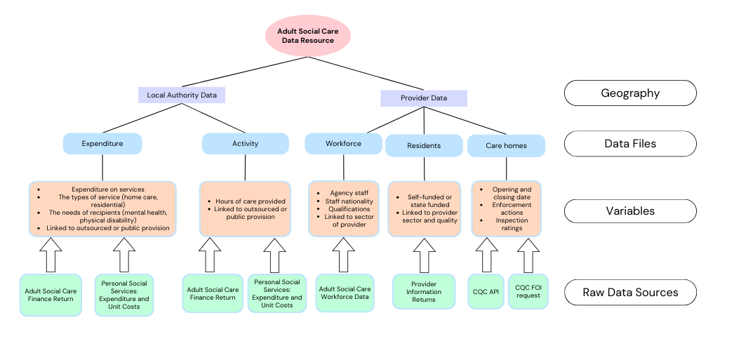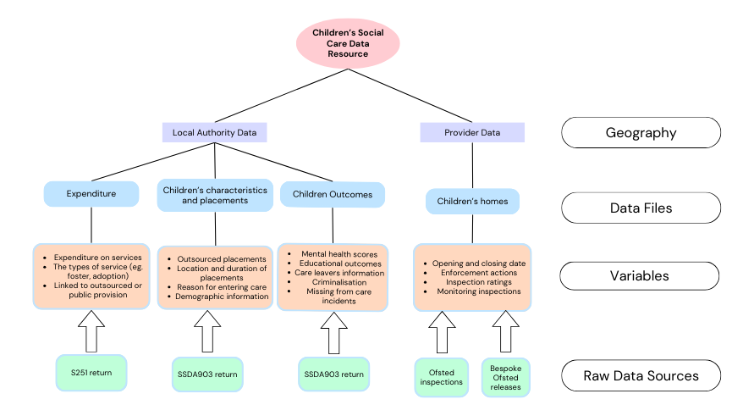

## Analysis

In this section, we present selected summary findings from the data resource. We primarily report data and trends relating to three areas: 1) the extent of social care outsourcing; 2) inspection outcomes and quality of care; 3) geographic accessibility and availability. For all areas, we report separately on children’s and adult social care.

### The degree of outsourcing

Both adult and children’s social care services have seen substantial increases in outsourcing in recent years. For each sector, we report on this using three general measures of outsourcing: expenditure on private companies, the number of placements in the private sector, and the number of residential providers (adult care homes and children’s homes) in each sector. Below, we first present the results for adult social care, then children’s social care, before discussing the similarities and differences in data, measurement and results.

#### Adult social care

Adult social care services have been almost entirely outsourced. Figure 2 displays the reported expenditure from each Local Authority going to “external” provision [1]. The figure shows that the average expenditure on outsourced provision was around 60% in 2001 and increased to 90% by 2023 (Figure 2, panel A).

**Figure 2:** Local Authority expenditure on outsourced Adult Social Care

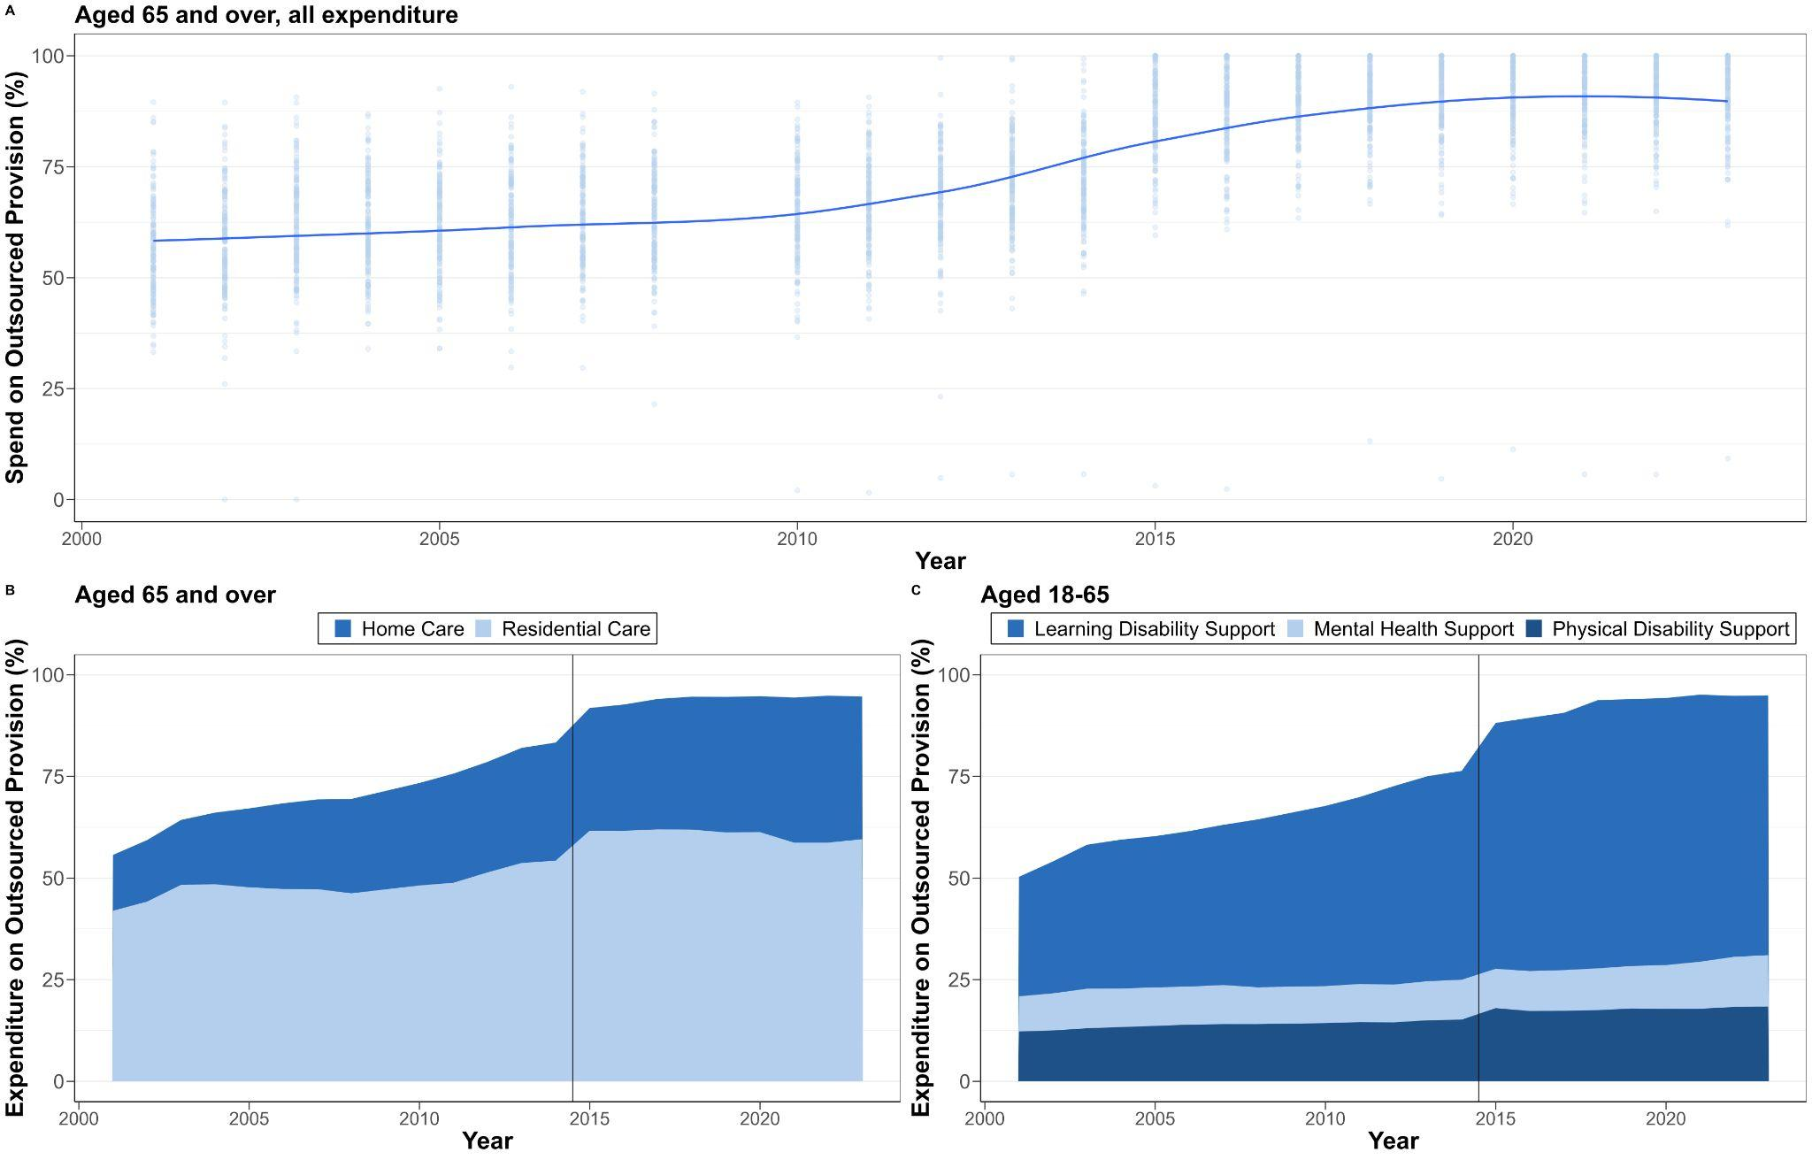

Note: Outsourced provision refers to private for-profit and third sector providers.

Figure 2, panel A, also shows the variation in outsourcing between Local Authorities is - and remains - large over the whole time period. While no LAs are outsourcing less in 2023 than in 2001, some have maintained their level of public provision. For example, Hertfordshire, reported an increase but started the time period as a high outsourcing Local Authority. Between 2001 and 2023 Hertfordshire reported a total £3.08bn expenditure on outsourced services, which is 89.6% of their total expenditure over the 22-year period. At the other end of the spectrum, Cumbria, which has untypically high levels of in-house provision, saw a decline from 53% to 37% in public expenditure between 2001 and 2023. This variation is an important finding in itself but, more importantly, it is an opportunity for future research to better understand the local authority level drivers and impacts of outsourcing.

Panels B and C in Figure 2 disaggregate this trend by residential and home care service and age group. We find that both residential and home care services for people aged 65 and over are almost entirely outsourced. We also see in Panel C that services have been heavily outsourced for adults aged 18-65 years across all care categories.

**Box 3:** Direct payments: an outsourcing experiment?

|  |
| --- |
| An interesting form of outsourcing in adult social care is that of expenditure on ‘Direct Payments’. Heavily promoted in the early 2010s, it was based on the idea that service users could be empowered as consumers if they were given the funds to directly purchase their own services, rather than letting the Local Authority organise the care. In many ways, this represents a radical form of outsourcing, whereby the market is no longer managed by a state commissioner, but by individuals tasked with purchasing responsibility [(Needham 2024)](https://www.zotero.org/google-docs/?broken=7hXM38). In Figure 3, we corroborate reports from other sources that there have been recent falls in the use of direct payments [(The King’s Fund 2024)](https://www.zotero.org/google-docs/?KbUIg5). However, with our data resource, we can also track its historic uptake, which peaked in the mid 2010s when around 5% of all expenditure went directly to service users for them to purchase their own care.  **Figure 3:** Local Authority expenditure on direct payments |

**Figure 4:** Local Authority residential placements in outsourced settings

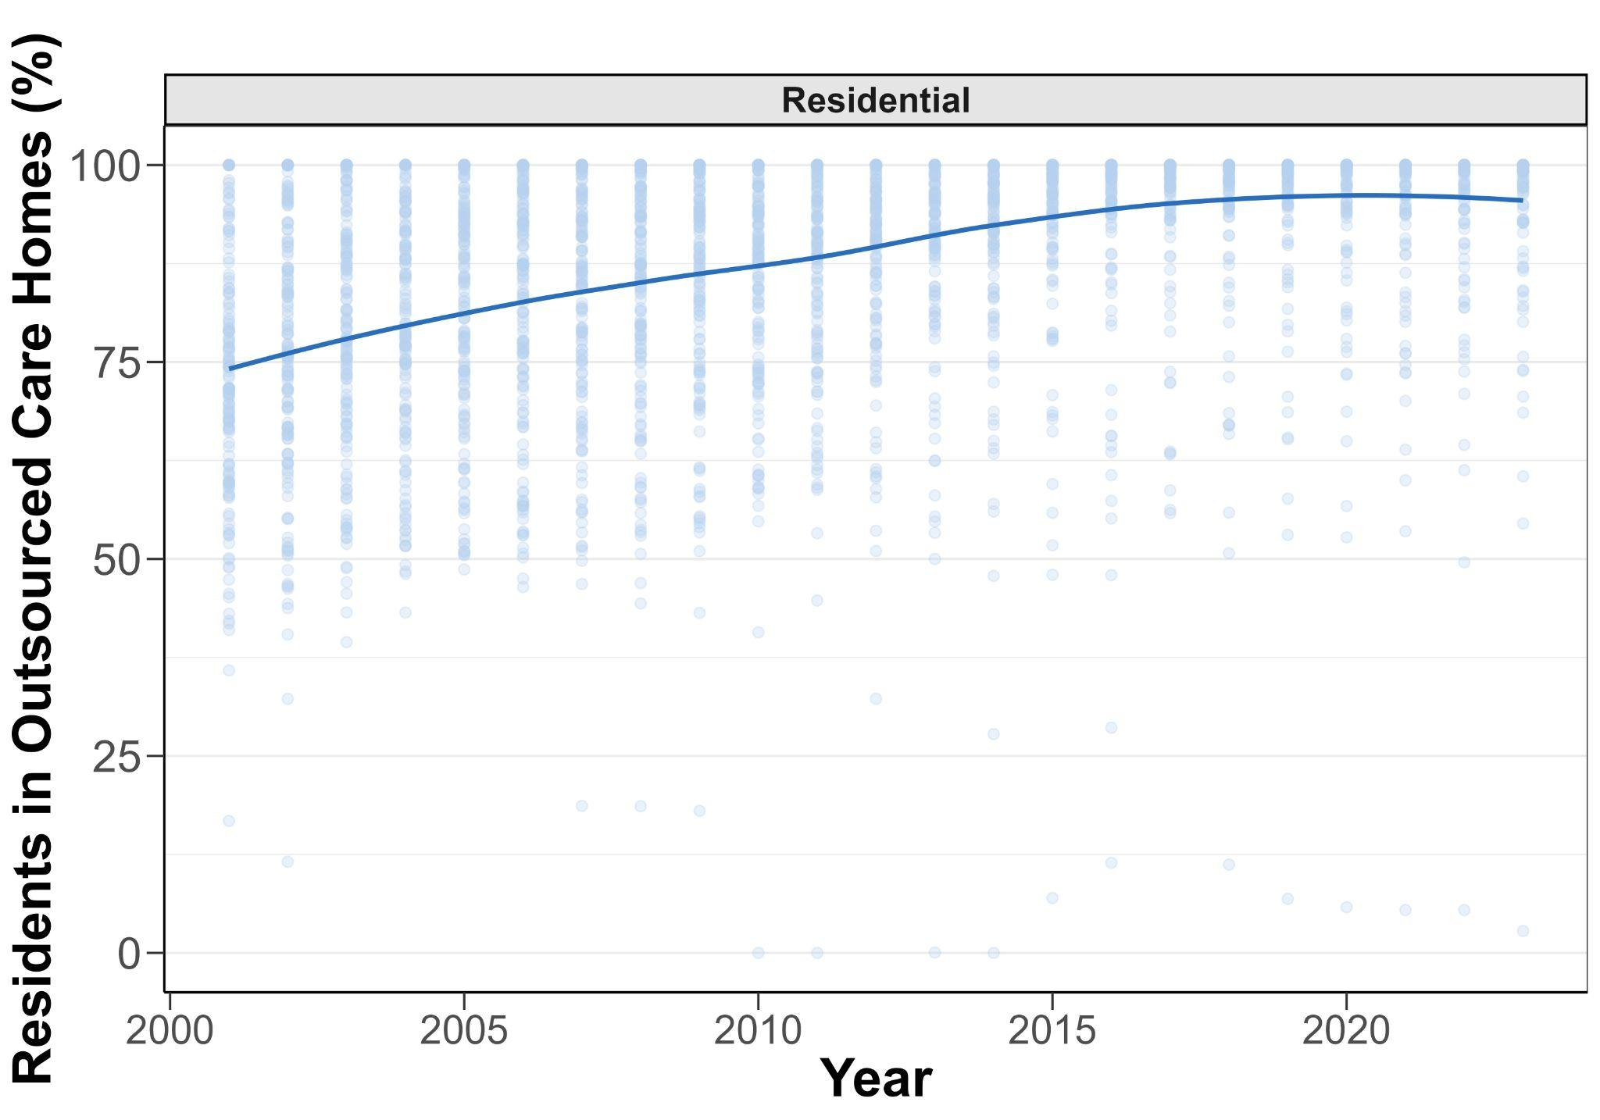

Figures 4 and 5 add to the picture. Figure 4 shows the percent of all residents in private homes, including third and private sector provision. It shows that almost all residents are now accommodated in outsourced provision. Figure 5 shows the changes in the number and percentage of for-profit, third sector, and LA providers/beds for residential care. It shows that more than 85% of all care homes and 88.7% of registered beds in England are currently (September 2023) operated by for-profit providers, whereas 11.9% are operated by third sector homes, and less than 3% are run by local authorities. Both figures show that the trends in outsourced expenditure roughly matches the number and percentage of outsourced providers and places.

**Figure 5:** Growth in the number of for-profit adult care homes and beds

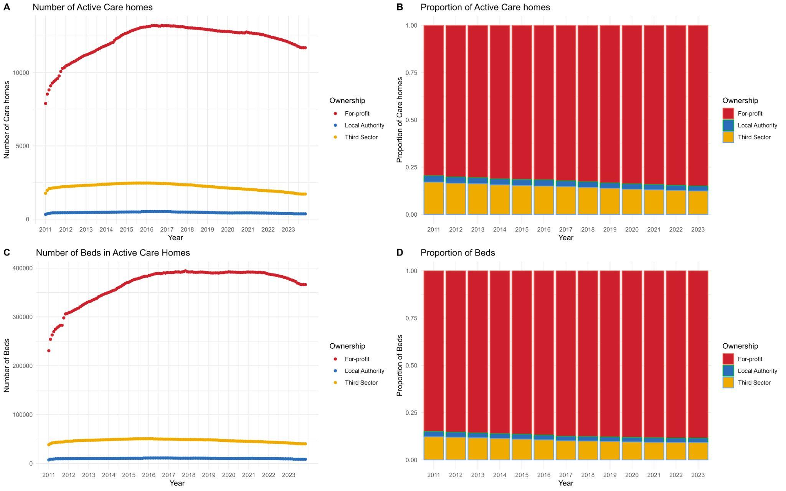

#### Children’s social care

Figure 6 displays the total reported outsourced expenditure broken down by the percentage going to for-profit and third sector provision. Panel a shows that average outsourcing expenditure has increased from 43.5% to 50.9%. Panel b shows that although outsourcing has generally increased, the relative expenditure on third sector provision has actually declined. This suggests a shift in the type of outsourcing towards for-profit companies over the last 10 years.

**Figure 6:** Local Authority expenditure on outsourced children’s social care, 2010-2023

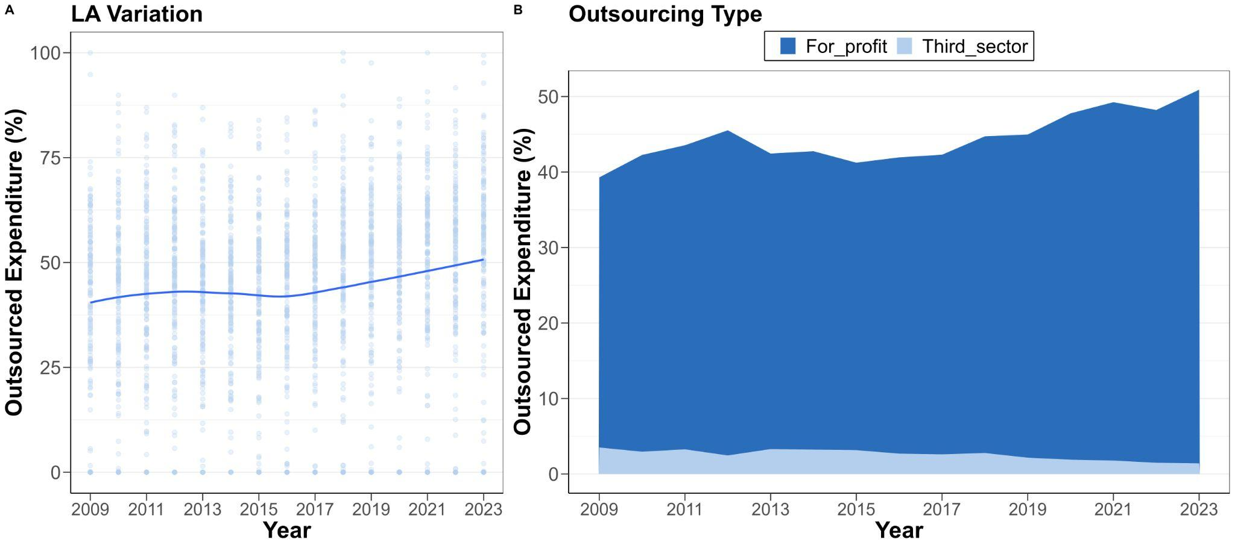

Figure 7 illustrates the changes in outsourcing across different service categories, 2010-2023 [(DFE 2021)](https://www.zotero.org/google-docs/?Ph9kRS). It shows that outsourcing expenditure has increased in all service categories, except for adoption. The figure further highlights how the extent of outsourcing varies by service group. The most outsourced service is residential care, for which, on average, 74.3% of the expenditure goes to private provision.

**Figure 7:** Outsourced expenditure for children’s social care broken down by service type, 2010-2023.

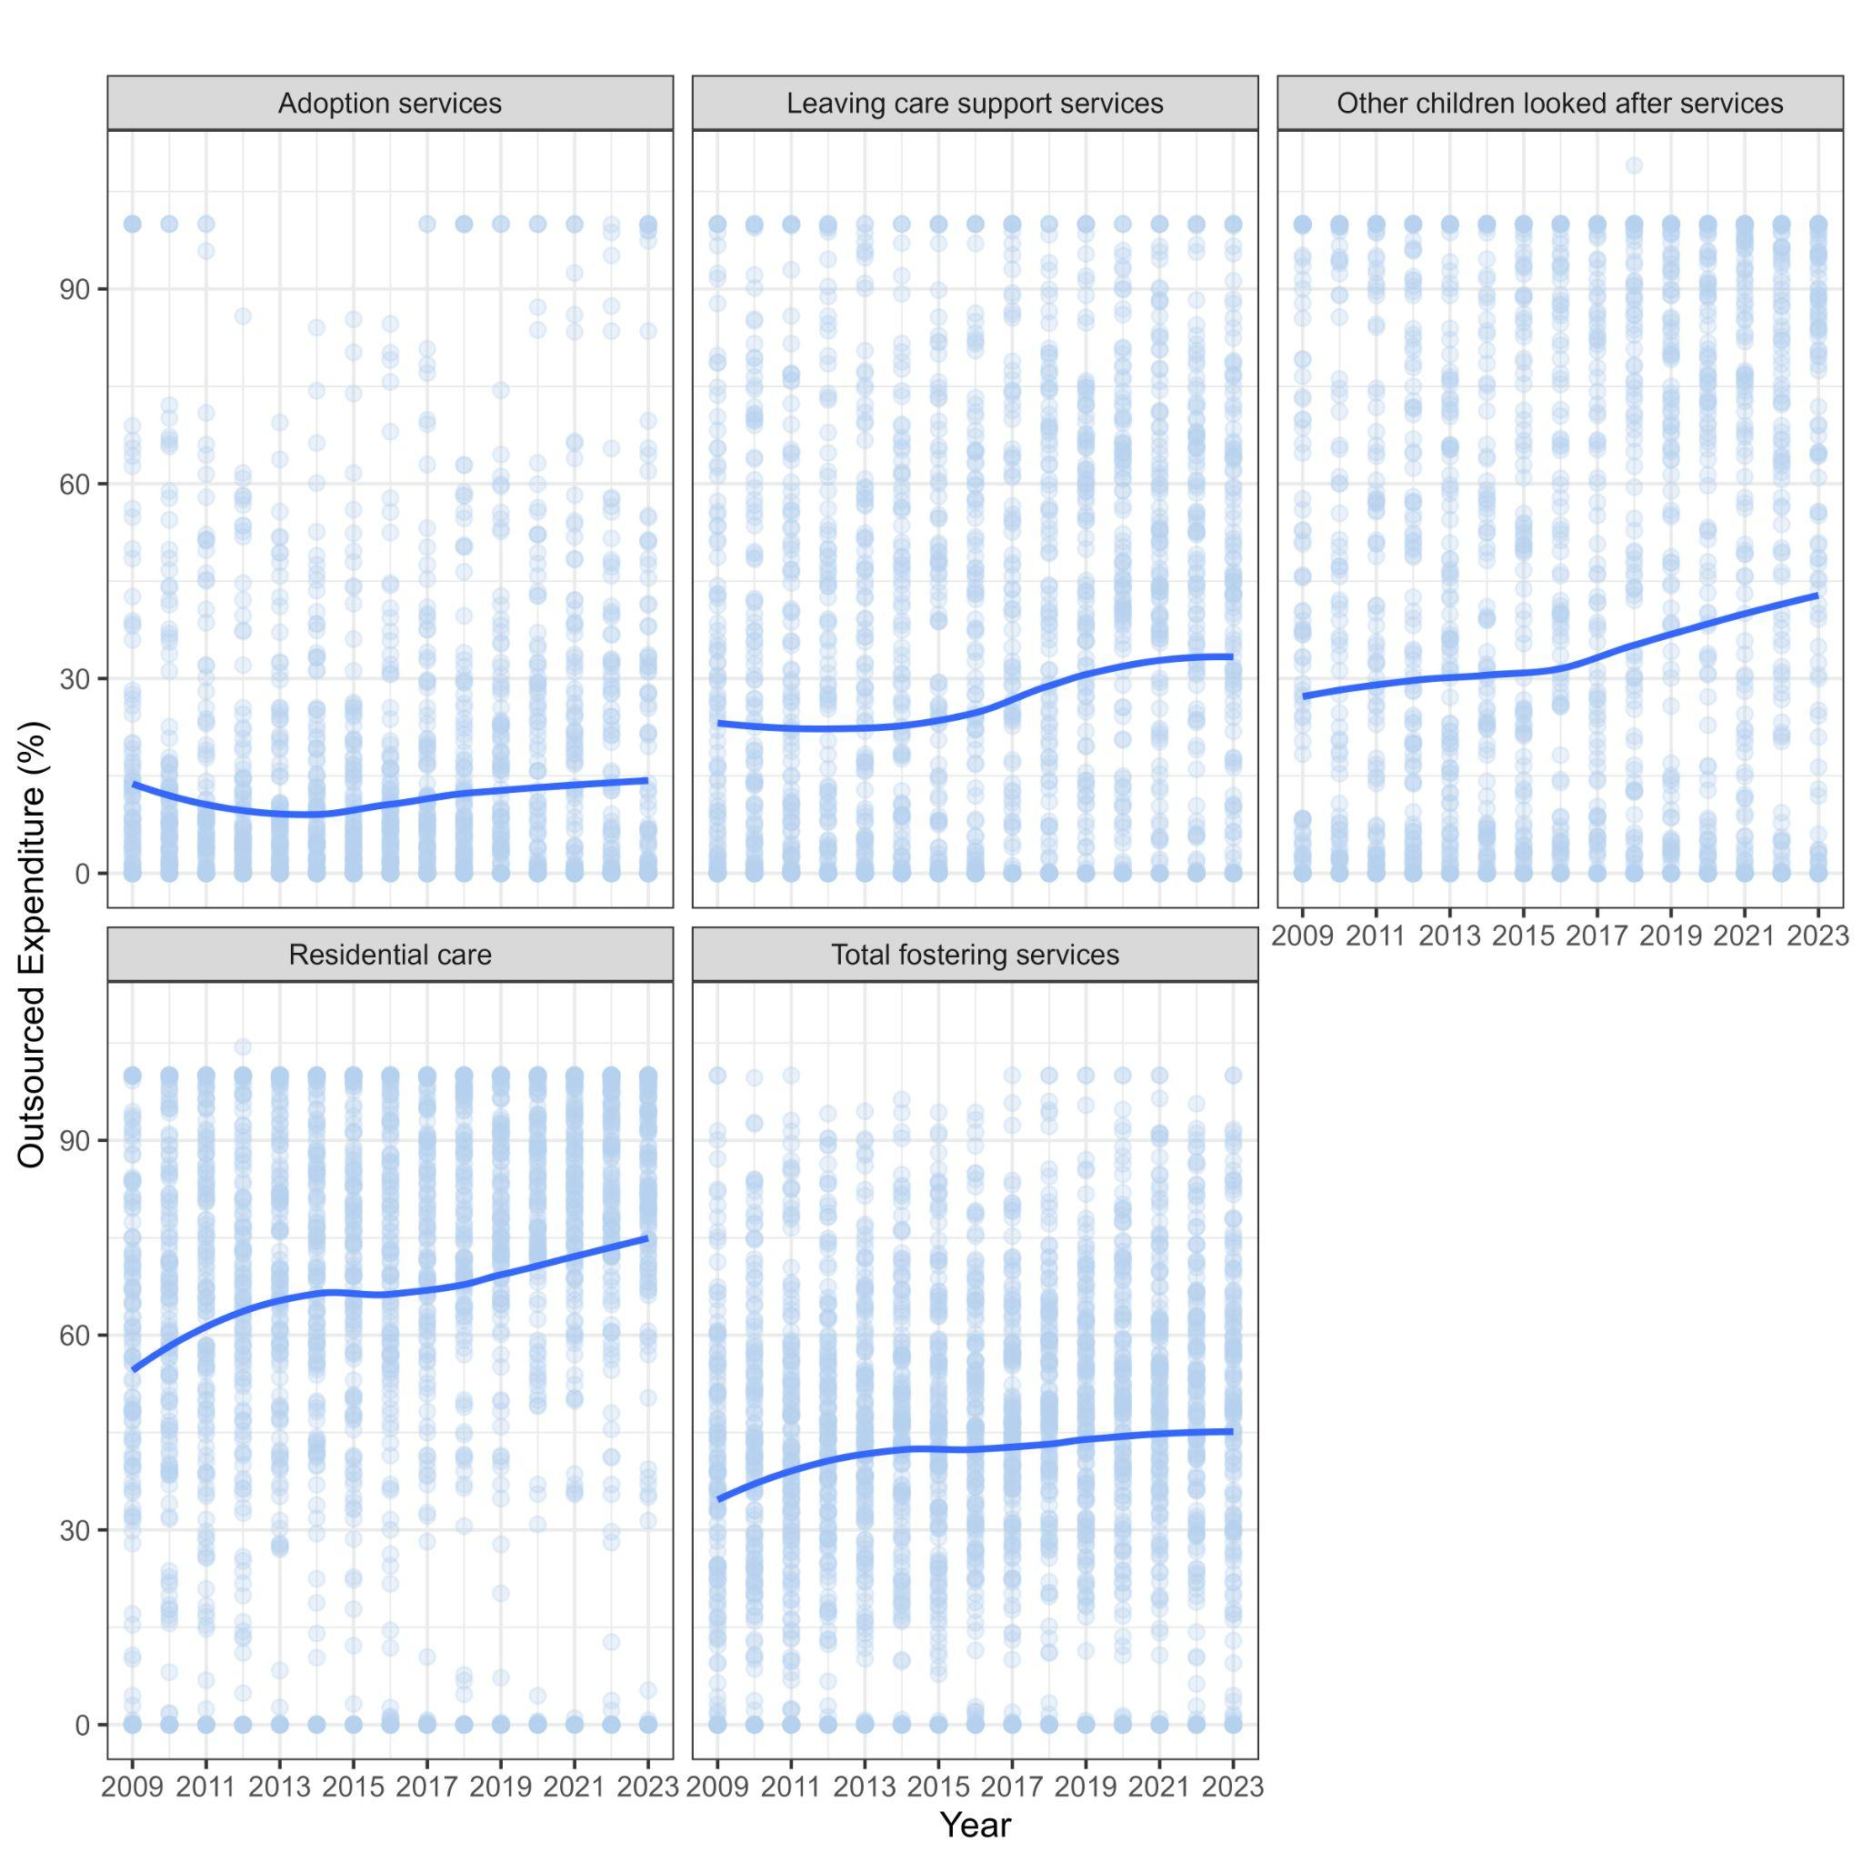

Figure 8 displays the changes in children’s social care placements over the same period. It generally mirrors the same pattern as in Figures 6 and 7, in that the percentage of outsourced placements has increased from 30.5 to 44.5 % from 2011-2023. It also shows that even though third sector expenditure has decreased, the proportion of third sector placements have increased from 3.1% to 6.3%. This apparent contradiction of increasing third sector placements and reduced third sector expenditure might be because expenditure does not fully mirror the number of services provided. A closer inspection of contracts between LAs and providers, as well as more granular expenditure data might help us understand why third sector places represent a substantially smaller amount of the expenditure relative to for-profit places.

**Figure 8:** Changes in the percentage of outsourced placements by year and local authority

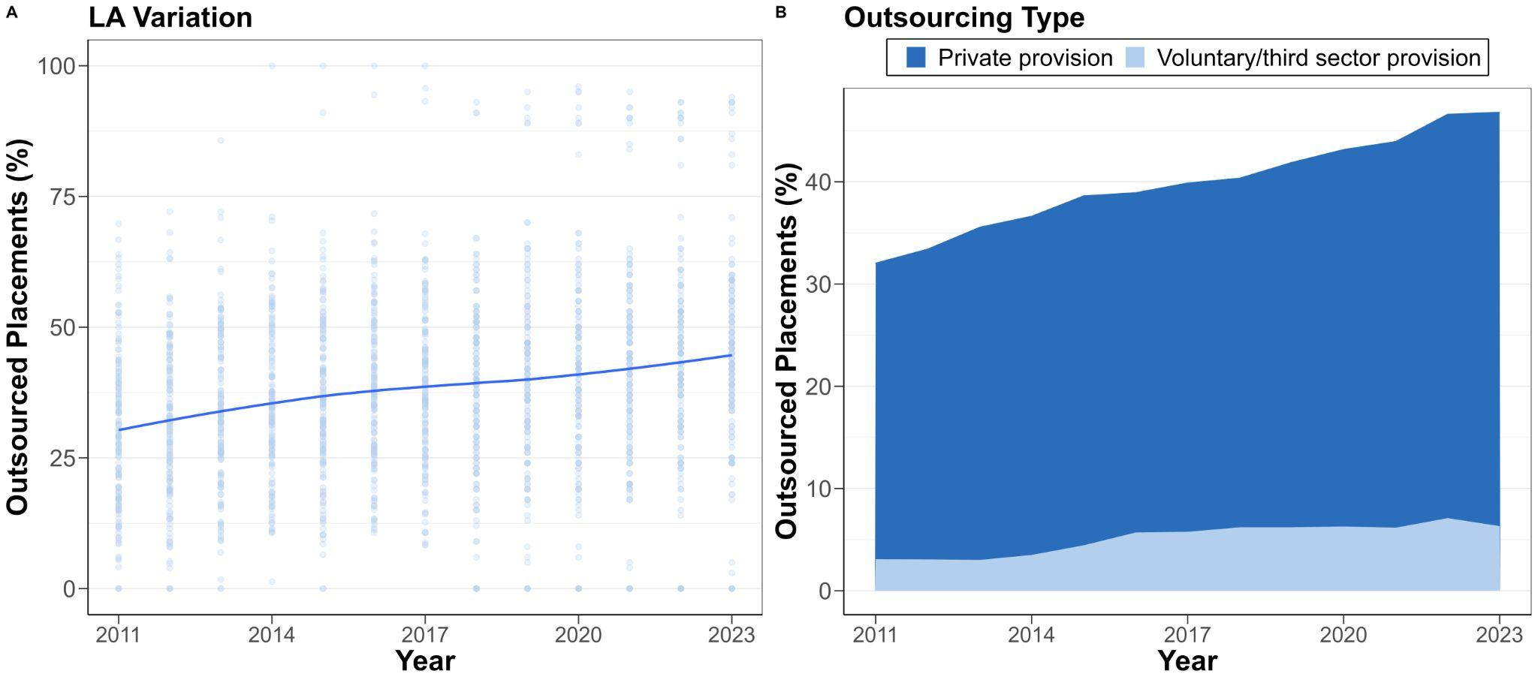

We can also estimate the rise in the number of for-profit children’s homes (figure x, technical appendix). However, there is only available data on the starting and closing date of children’s homes after 2018. This means that we can accurately plot how the number of homes has increased over time, but that we cannot track the start date of homes that closed before 2018. Of the children’s homes that were active after 2018, there were as many LA-run as for-profit homes in 2004. However, for-profit provision has accelerated in the last 10 years, and by 2023, more than 80% of all homes were in the for-profit sector (figure x, technical appendix).

### Outsourcing and quality

Below, we will discuss trends in quality-related outcomes. The main quality outcomes for each sector are Ofsted and CQC inspection ratings. These are given at provider level but are meant to reflect overall practices and resident experiences (see appendix X for the domains used in each sector). These are the primary tools in terms of regulation and are also the most commonly used and discussed outcomes in both sectors. However, it is well understood within adult and children’s social care that inspection ratings do not always reflect practice. Therefore, we also present trends in additional quality-related outcomes, such as provider cancellations, and placement distance for children’s social care.

**Box 4:** Regulations for cancelled registration of social care providers

|  |
| --- |
| Both the CQC and Ofsted - as the main regulator of adult and children’s social care - have the power to cancel the registration of providers that pose a risk to residents or fail to meet standards. This power is meant as a last resort to safeguard residents from harmful practices. However, very little is known about how often each regulator uses this power, and what providers are most commonly closed via enforcement.  **Adult social care:** The Care Quality Commission can cancel a registration as a sanction for care homes that fail to adhere to their requirements and safety standards. The CQC will only consider cancelling a registration if people receiving care have either “…*suffered harm or are at risk of harm because a registered person is failing to comply with legal requirements.*”; or “*Are receiving care services that substantially fail to meet the standards set out in the regulations.*” [(CQC 2022)](https://www.zotero.org/google-docs/?X2O5h5). A cancellation will typically only be considered after significant efforts to ensure compliance with legal requirements, and care homes that have been rated as inadequate will typically be put into ‘special measures’ [(CQC 2023b)](https://www.zotero.org/google-docs/?jZJ5bi), which involves more frequent scrutiny and inspection. However, enforcement can be implemented with immediate effect if the risk of harm is acute or in instances of very severe safety and regulation breaches. If providers continue operating after their registration has been cancelled, it will be considered a criminal offense.  **Children’s social care:** Ofsted may cancel a provider registration for the following reasons: (1) The registered person has been convicted of a relevant offence. (2) Any other person has been convicted of a relevant offence in relation to the establishment or agency. (3) The establishment or agency is being, or has at any time been, carried on or managed without complying with the relevant requirements. (4) The registered person has failed to comply with a compliance notice. (5) The registered person has failed to pay a prescribed fee. (6) The registered person has made false or misleading statements or provided false information during the registration process. (7) The establishment or agency has ceased to be financially viable or is likely to cease to be so within the next 6 months [(Ofsted 2024b)](https://www.zotero.org/google-docs/?ekp7pN).  In making the decision to cancel a registration, Ofsted considers factors like the seriousness of the concerns, risks to children, compliance history, and the provider's ability to improve. Ofsted generally tries other enforcement actions first before cancelling, unless there is an urgent risk to children's life or wellbeing that warrants immediately seeking an urgent cancellation order. |

#### Adult social care

***CQC inspection ratings***

Figure 9 shows the percent of care homes rated as either “good” or “outstanding” for their overall CQC inspection rating as a rolling 1-year average. It shows that for-profit providers have consistently, from 2016-2023, been rated worse than other ownership types. It also highlights a large dip in inspection outcomes during the COVID-19 pandemic, which seemed to impact the quality of for-profit and third sector homes the hardest.

**Figure 9:** Homes rated Outstanding or Good by ownership status 2014-2023, England.

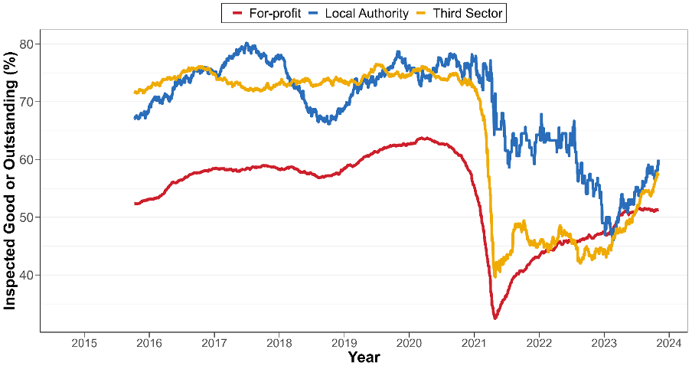

**Note**: Figure shows a rolling, 1-year average of the % of care home inspections performed on care which are rated either Good or Outstanding for their overall rating – broken down by ownership status.

**Figure 10:** Voluntary and involuntary closures by provider and registered beds, 2011-2023.

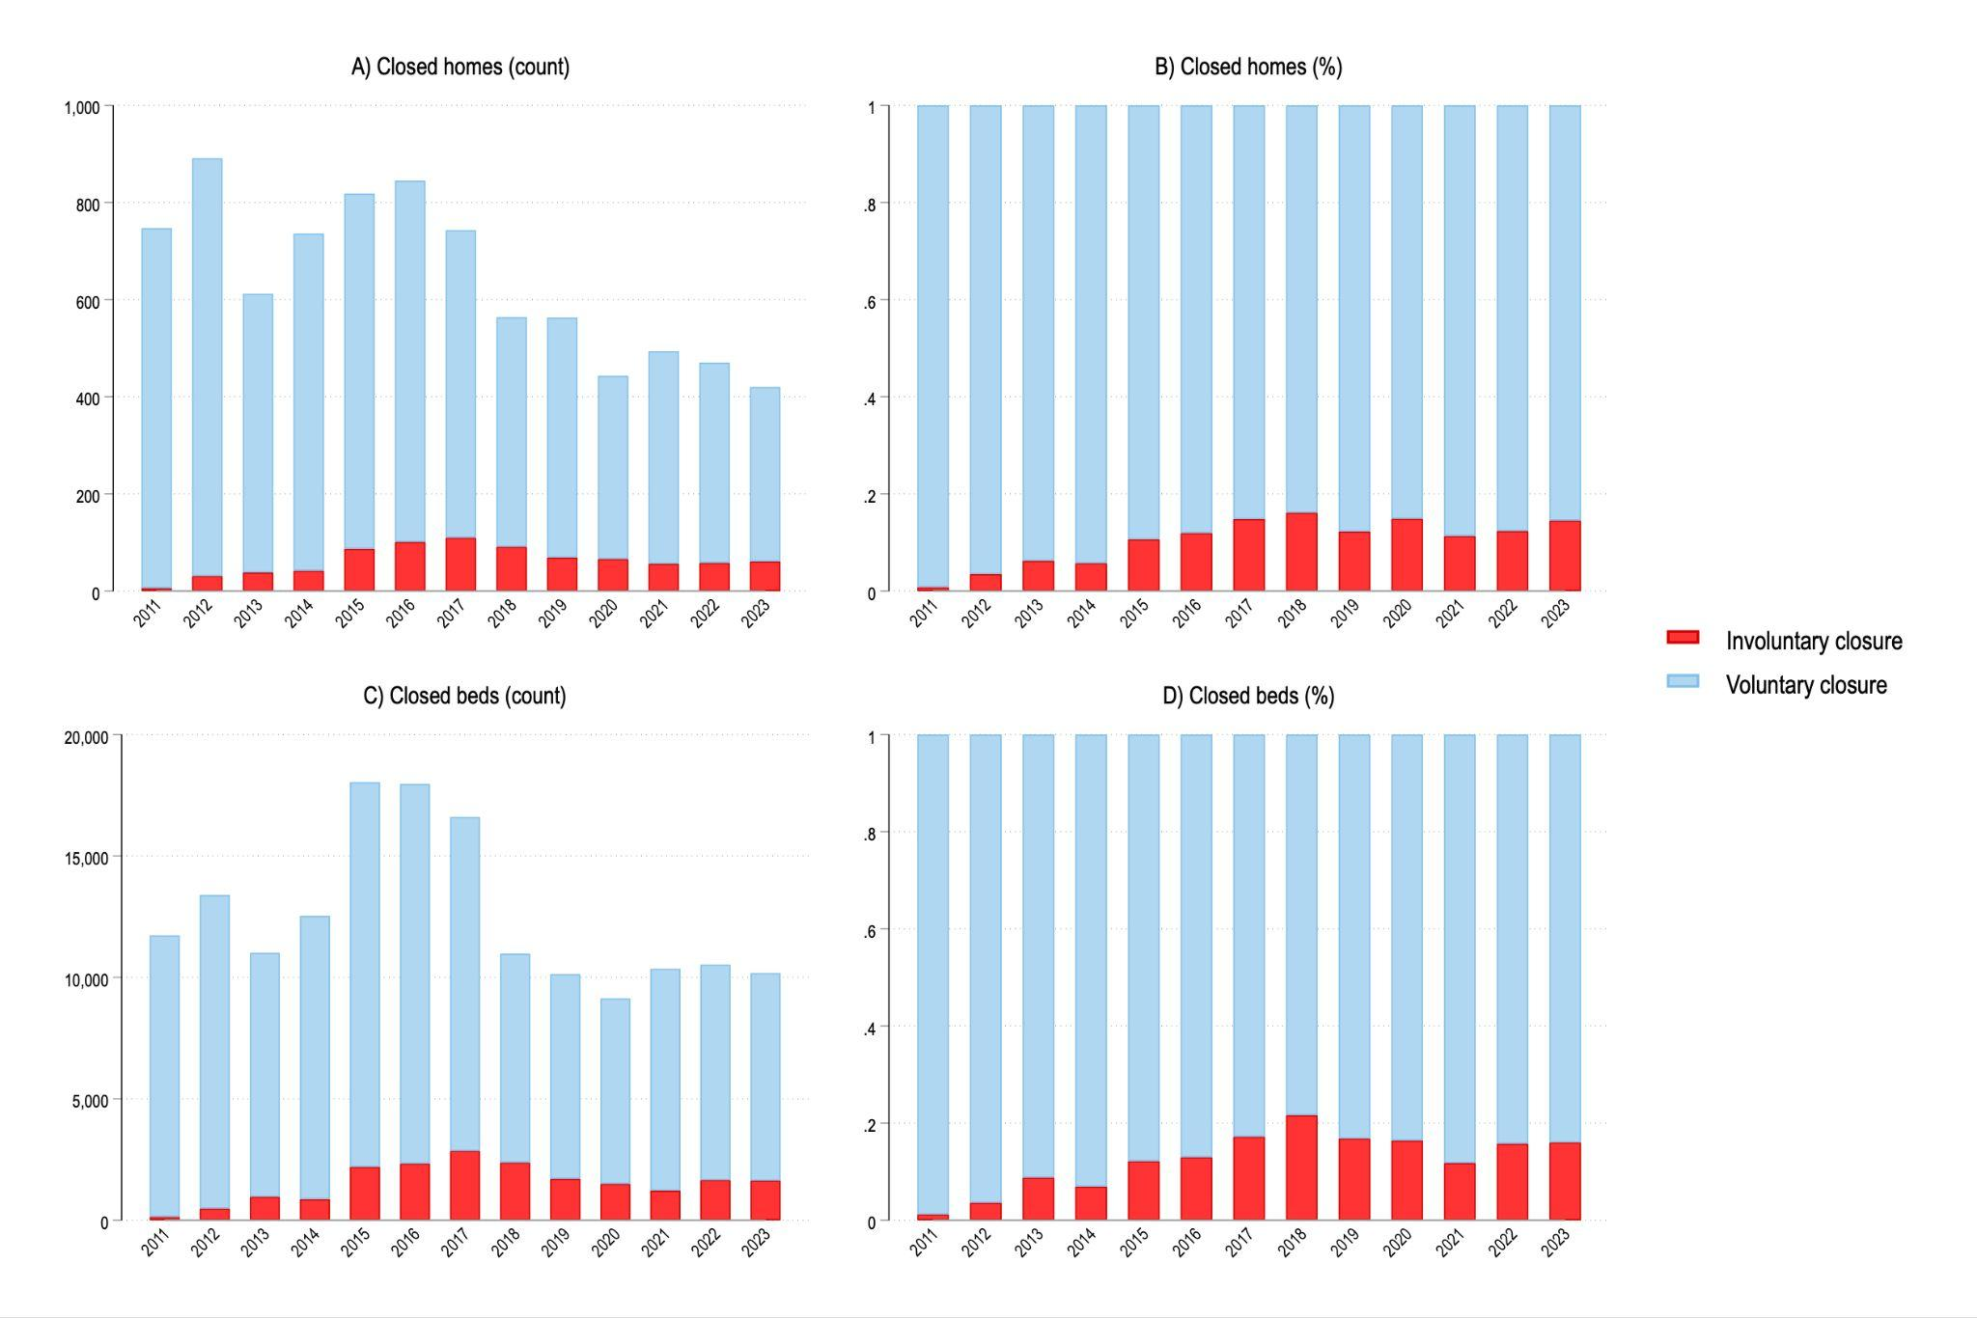

***Involuntary closures of residential care homes***

Figure 10 shows that 816 involuntary care home closures (representing 19,918 registered beds) were recorded from 2011 to September 2023 and that this number is increasing. More than 16% (61/377) of care home closures in England in 2023 (as of September) were because of an enforcement. This is an increase of more than 10 % compared to 2012 and 2011 (see page 4, Figure X in the Appendix). The impact of involuntary closures is even higher when looking at the proportion of registered beds (see Panels C and D in Figure 2). In 2022 and 2023 (as of September) 15.75% and 18.36%, respectively, of closed beds were the result of an involuntary closure.

Table X in the appendix shows that effectively all care homes that have been subject to an involuntary closure (804/816) were run by for-profit provision. From 2011 to September 2023, 816 involuntary care home closures (representing 19,918 registered beds) were recorded, and all except for 12 of these events occurred to for-profit care homes [2].

#### Children’s social care

We tracked and compiled all full Ofsted inspections on children’s homes since 2014. Figure 11 shows the percent of children’s homes rated as “good” or “outstanding” in their overall Ofsted inspection rating as a rolling 1-year average. Local Authority and third sector children’s homes have on average received better inspection ratings than for-profit provision. It further shows that there was a break in routine inspections for a full year following the COVID-19 outbreak. Since the reintroduction of full inspections in 2021, average ratings for providers have decreased following the pandemic. In consequence, ownership differences have decreased - not because for-profit children’s homes are performing better than before, but because both LA and for-profit children’s homes are, on average, receiving worse ratings than before the pandemic. Notably, third sector children’s homes are the only sector that have recovered pre-pandemic level of ratings. However, these only consist of 5% of the market.

**Figure 11:** Children’s homes rated ‘Good’ or ‘Outstanding’ by ownership status, 2015-2023.

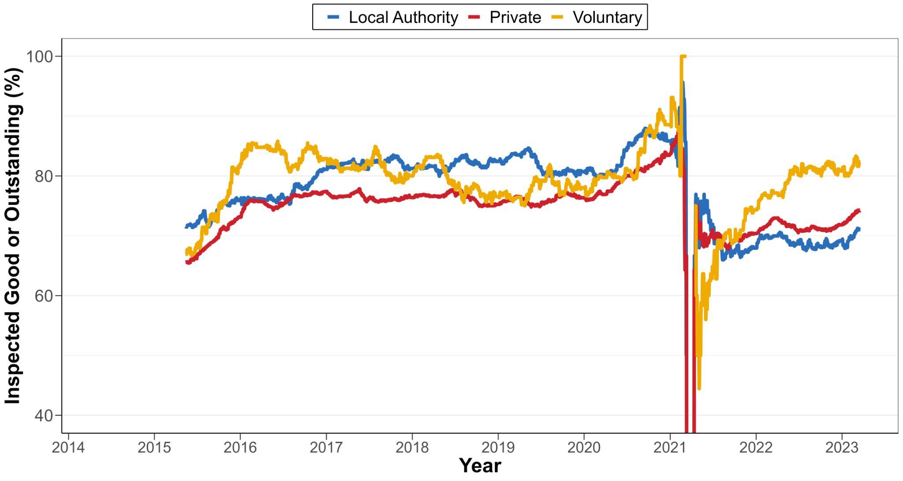

Ofsted will also conduct a ‘monitoring inspection’ if children’s homes have a) been rated inadequate b) been given compliance notes or enforcements, or c) if Ofsted have concerns that are best addressed and resolved via a monitoring visit [(Ofsted 2024a)](https://www.zotero.org/google-docs/?UQD7Iw). Figure 12 shows the percent of all inspections which are monitoring inspections to respond to quality concerns. It shows a similar trend as the full inspections: Before the outbreak of COVID-19, for-profit children’s homes were consistently the worst performing, but these trends changed more recently.

**Figure 12:** Proportion of monitoring inspections by ownership in children’s homes, 2015-2023

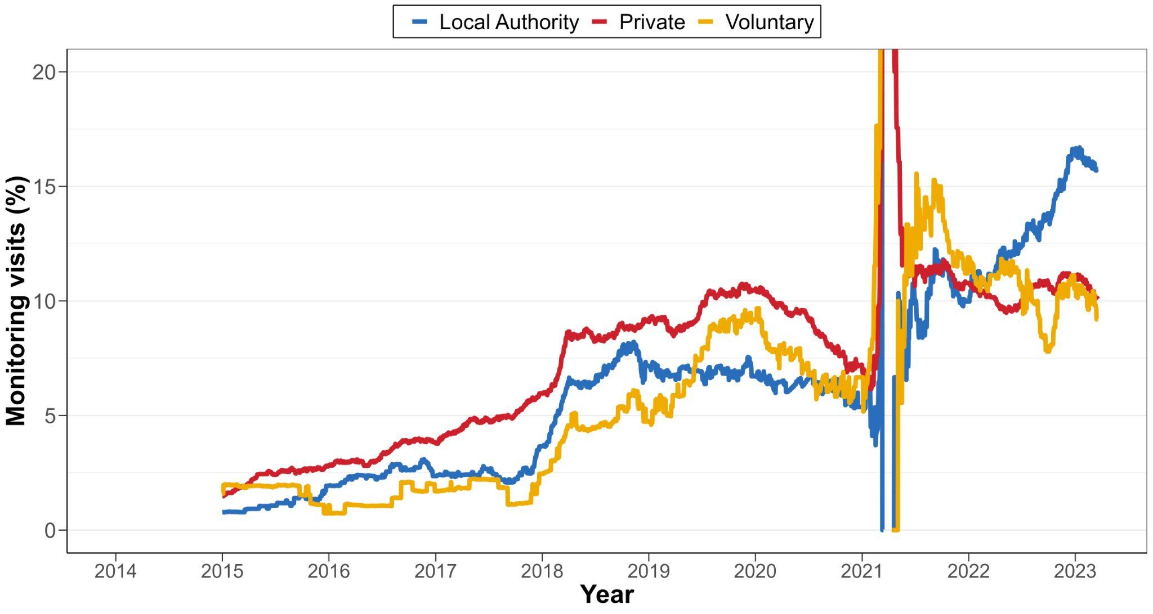

***Cancellations***

The data on cancelled children’s home providers has, like adult care homes, not been consistently reported on over time. Ofsted has not released consistent data on children’s home opening and closures until 2018. Through a freedom of information request to Ofsted, we were able to get a complete list of voluntary resignations and involuntary cancellations of children’s homes with closure dates, 2014-2024. However, because the registration start date is not reported, it is not possible to track closure and openings with the same level of detail as with adult care homes.

The data allows us to track voluntary and involuntary closures at provider level since 2014. Table 2 shows that from 2014-2023 only 53 care homes were involuntarily closed by Ofsted, which is 4.13% of all closures. We found that 90.6% (48/53) of the cancelled homes were run by for-profit providers, which means that for-profit homes are overrepresented relative to the market share over the same period. Out of all for-profit children’s home closures, more than 5% involve a cancellation, whereas this is only 0.9% and 2.5% for LA and third sector closures, respectively.

**Table 2:** Cancellations and voluntary resignations of children’s homes, 2014-2023.

|  |  |  |  |
| --- | --- | --- | --- |
| Ownership | Cancelled (%) | Voluntary closure (%) | Total |
| For-profit | 48 (5.2%) | 883 (94.8%) | 929 |
| Local Authority | 2 (0.9%) | 230 (99.1%) | 232 |
| Third sector | 3 (2.4%) | 121 (97.6%) | 124 |
| Total | 53 | 1232 | 1285 |

### Outsourcing and equality of access

In the following, we will discuss trends in terms of the availability and accessibility of social care provision. A key feature of the care crisis in both sectors is the lack of sufficiency. It is often reported that unmet and undermet adult social care is increasing, and, similarly, the demand for children’s social care places exceeds supply. This is sometimes linked to area characteristics, such as deprivation, but it is unclear how outsourcing, quality, and area characteristics are connected. Below, we will focus on where care homes and children’s homes open and close, and how this relates to area deprivation and inspection outcomes.

#### Adult social care

Figure 13 shows the distribution of inspection ratings for active and closed homes, 2014-2023. It shows that closed for-profit homes are generally rated worse than active homes, suggesting that quality plays an important role in care home survival. However, this pattern is not mirrored in LA and third sector homes, for which there are no clear quality differences between closed and active providers.

**Figure 13:** Distribution of inspection outcomes for active and closed homes across ownership and IDAOPI deciles.

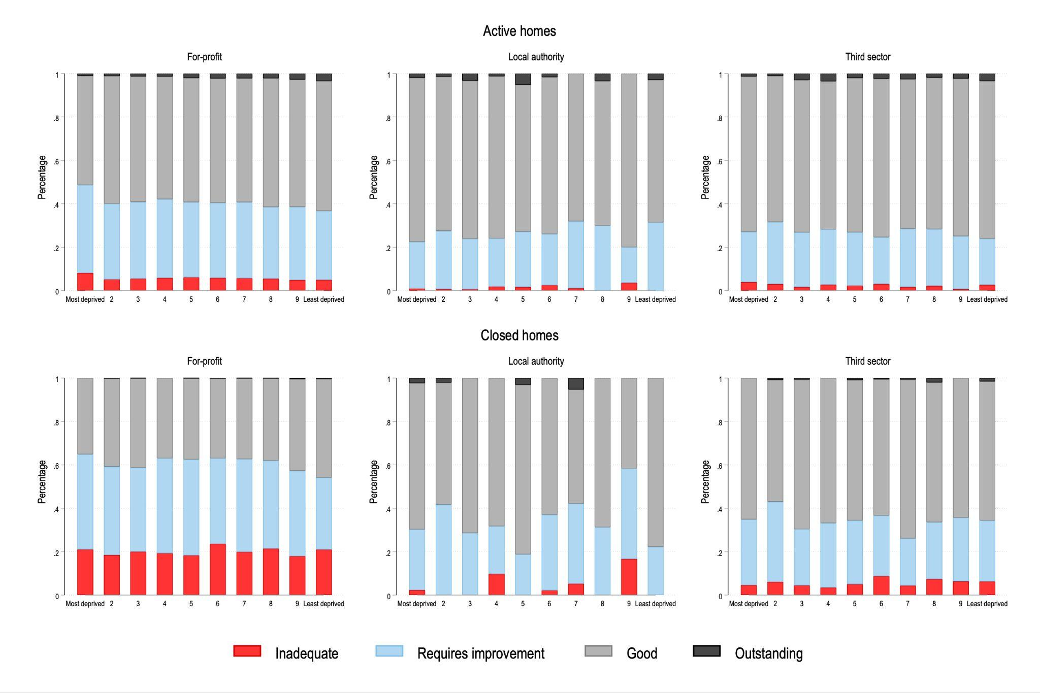

Figure 14 uses Provider Information Return from the CQC and displays the number (panel a) and percentage (panel b) of self-funded residents by ownership categories and deprivation deciles. The data reveals a clear connection between area deprivation and the proportion of self-funders for both for-profit and third sector provision, but not for LA homes. This connection is not surprising, in that the eligibility criteria for receiving state-funded care is determined by residents’ savings and asset value, and that less deprived areas will, on average, have a higher proportion of residents that do not meet the eligibility threshold for state-funded care.

However, it appears that the focus on self-funders is strongest in for-profit provision. On average 27.1% of for-profit care home residents are self-funded, compared to 23.5% and 10.2% for the third and public sector. Figure 15 shows that funding status also influences quality, but only in the for-profit sector. For-profit homes rated “Inadequate” or “Requires improvement” have a lower proportion of self-funded residents compared to homes rated ‘Good’ or ‘Outstanding’. The proportion of state/self-funded residents does not impact quality in third sector and LA homes.

This suggests not only that for-profit provision is increasingly focused on self-funded residents, but also that services with more self-funders are, on average, of higher quality. This may have implications for service equity and accessibility. If the survival of care homes is determined by access to self-funders, it can lead to severe equity issues, in which competition for quality primarily applies to prosperous areas, leaving residents in poorer areas without access to the care they need.

**Figure 14:** Resident mix by ownership and IDAOPI deciles 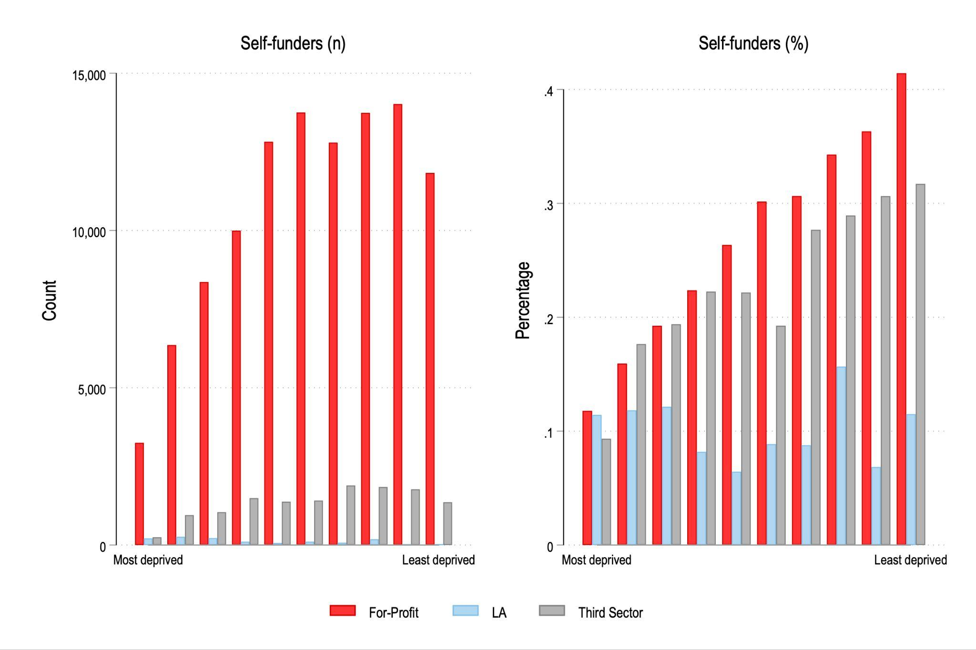

**Figure 15:** Funding status by ownership and quality.

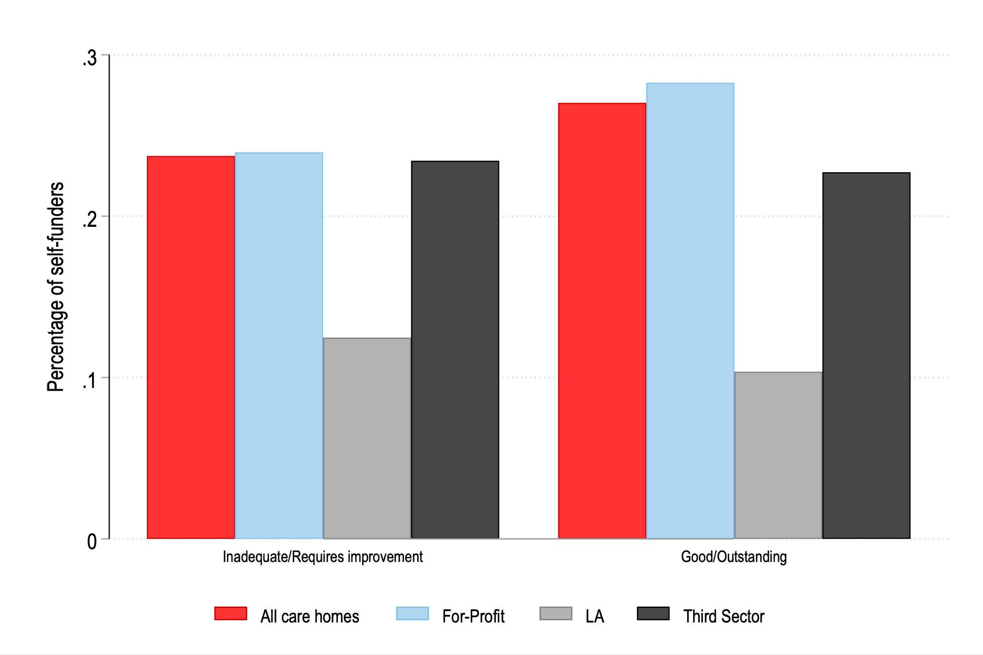

#### Children’s social care

***Distance/stability***

Figure 16 shows that there is large variation in the proportion of out-of-area placements across LAs. Some LAs place almost all children within their boundary, whereas others place all or most children in other LAs. Panel B of Fig. 1 shows that rural LAs have the fewest children placed outside their boundary. Panel C shows that the issue of placing children within the responsible LA is particularly acute for the Inner London region.

Across all LAs in our sample, there has been a slight increase in the percentage of children being placed at distance: in 2011, 39% of the children in care on March 31st were placed outside their home LA boundary, and by 2022 this had increased to 43 %.

Most children in care have not been in the same placement continuously for over 2 years (Figure 15, panels D–F). This is partly because many of the children in care will not have been in care for the 2.5 years necessary to be counted in this measure, or due to placement changes. When looking at long-term stability as the proportion of children who have been looked-after for at least 2.5 years, Figure 16 shows that 70 % of children in this category have been in the same placement for at least 2 years (2022), which is three percentage points less than in 2018 (73 %).

**Figure 16:** Placement outcomes by year and local authority, 2011-2023

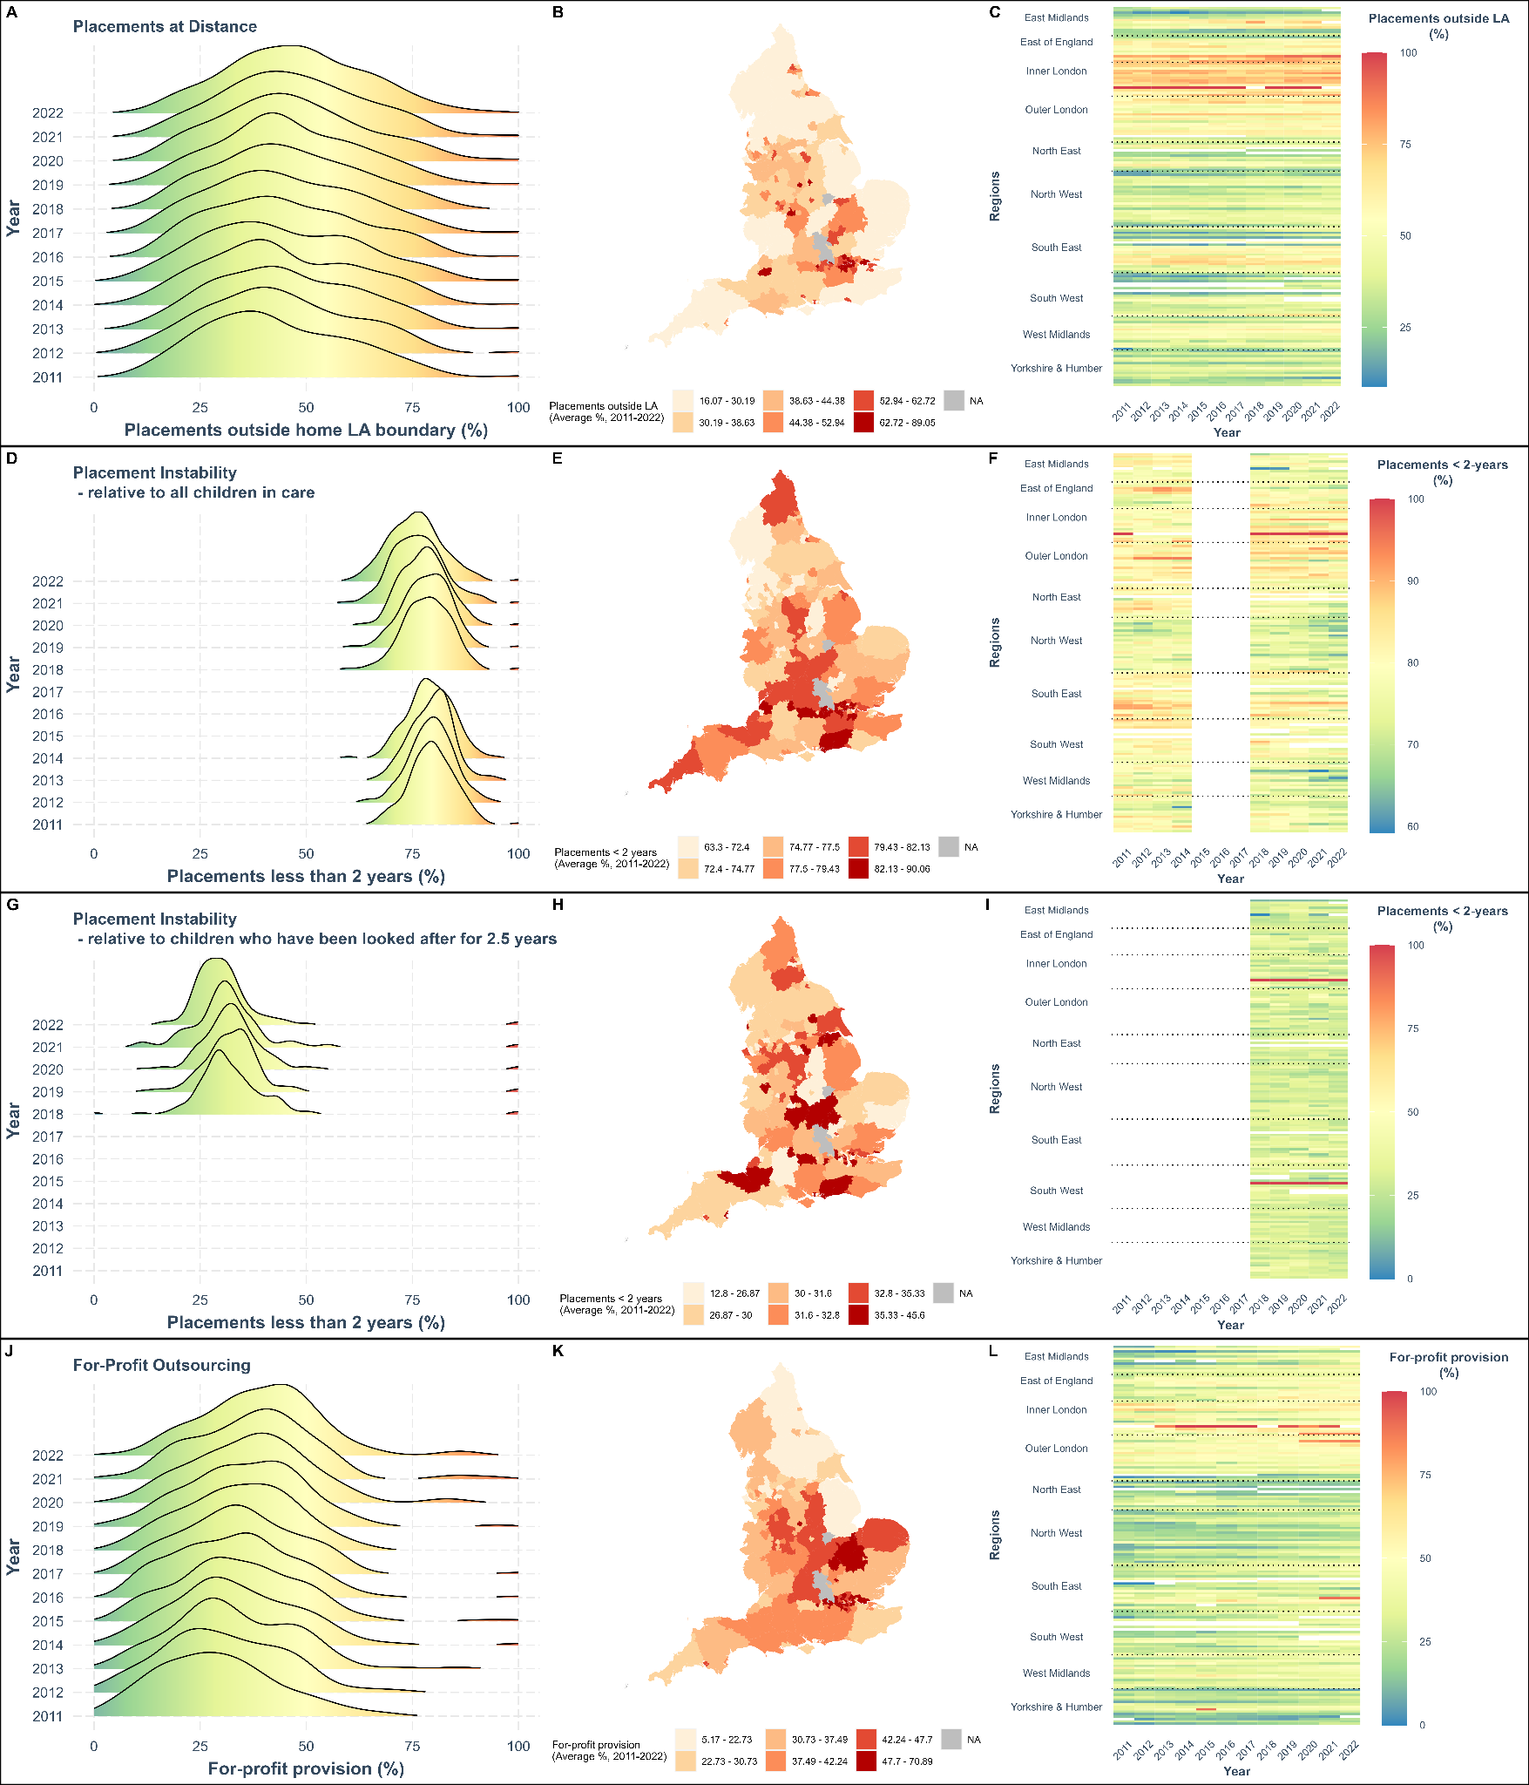

Figure x in the appendix displays the association between changes in for-profit outsourcing and in the placement outcomes over the full time-period. It shows that increases in for-profit outsourcing are positively associated with increasing out-of-area and unstable placements. [3]

**Opening and closures of children’s homes**

One reason that children are being sent out of their local area for care might be that providers are not locating themselves in areas of greatest need. An unintended consequence of the increasing for-profit children’s homes might be that profit-motivated providers are opening where it is cheapest to do so, rather than where the local need is the highest. Our dataset can show some of these trends. Figure 17 displays the net change (number of openings minus number of closures) in children’s homes between 2016 and 2023 by LA and according to IMD extent (the proportion of a local authority district's population living in the most deprived LSOAs in the country). Between 2016 and 2023, there were more LA and third sector children’s homes closures than openings. This occurred at an even rate irrespective of area deprivation. Not only did for-profit provision grow on average, but it did so the most in the poorest places and in areas with lower property prices (see figure x in the appendix). This might be because the for-profit sector is responding to increased need in those areas, but, given the poor local sufficiency and the increases in out-of-area placements, this could also reflect providers targeting areas with cheap property, regardless of the needs of those areas.

**Figure 17:** Net change in number of children’s homes and area deprivation, 2016-2023

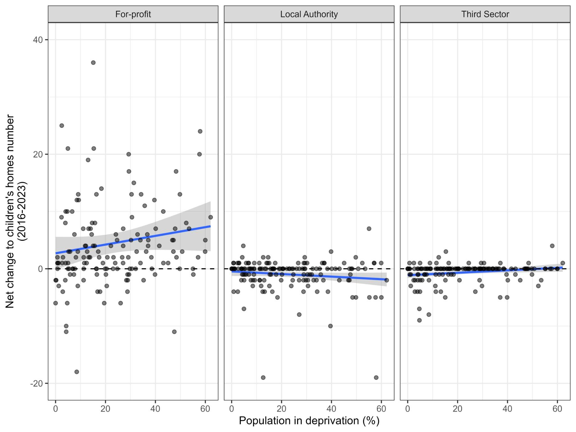

**Accessibility: a known unknown in children’s social care**

Across health and social care, there are many well developed and utilised measures for accessibility, but there are no equivalents for children in care. In other policy areas, there is detailed information on e.g., waiting times/lists, the percent of people using alternative services, delays in being released from hospital, or the number of people applying and not receiving services, but there are no similar outcomes for children in care. While we know that many children are placed away from their local area due to inadequate sufficiency, we do not know how many children are not receiving the services they need. Recent updates to the data have reported on the number of children placed in unregistered settings, but we do not know what this number is for the period before 2018 nor by LA, and it therefore cannot be used for analysis.

Qualitative research, analysing the experiences of key stakeholders, frequently identifies poor accessibility in children’s social care. A prime example of this is the research highlighting that placement decisions are not always made with the best interests of the child in mind [(A. Bach-Mortensen, Goodair, et al. 2022; Hart and Valle 2021)](https://www.zotero.org/google-docs/?CWVKqf). For example, it is widely understood that children are sometimes placed in children’s homes, even though they are best suited for alternative provision (e.g. foster care) due to inadequate foster provision. But how many children is this? Is this number rising? In which areas is it highest? The answer is that we just do not know. To understand the full extent of children who have no access and any inequalities in provision, we need better and fuller measures of accessibility - as in adult’s social care.

# 

# 

# 

# 

# 

# 

# 

# 

# Discussion

In this report, we have presented the results of our data harmonisation work to date on the outsourcing of adult and childrens’ social care in England. This project was motivated by the on-going care crisis in both sectors, and the accompanying discourse that reform is blocked by a lack of data. We have found that this need not be the case; there is a large amount of data tracking the development of adult and children’s social care provision, both in terms of outcomes, expenditure, and outsourcing. However, this data is not easily accessible, it is often fragmented, and data quality is variable (see box 6 for a list of data gaps in the sector).

The focus of this report has been to harmonise the substantial existing data on social care outsourcing, and to thereby create the data resource necessary to 1) evaluate the consequences of this development, and 2) identify data and evidence gaps. Below, we will discuss the main lessons and reflections based on our harmonisation work and the provisional analysis of the data. In doing so, we discuss how important questions can be addressed using the existing data and which questions cannot be answered with the publicly available information on the sectors.

**Box 5:** Data resource strengths and limitations

|  |
| --- |
| **What can our data do?**   * Track outsourcing over time   + Our data is longitudinal, which means it measures the same variables repeatedly over time. This is important, because it enables analysis of how changes in outsourcing relate to other outcomes, such as quality, closures, and sufficiency. * Compare trends geographically   + This data resource includes a number of LA or postcode level data, which enables geographically data linkage. This means we can connect this resource to many additional datasets, and see how different variables (eg. economic, political, or demographic) relate to each other at a geographical scale. * Provide detailed information on social care providers over time.   + We have collected the full publicly available registration and inspection history on residential children’s homes and adult social care providers, 2011-2023. This means that we can conduct detailed analysis of provider details, inspection outcomes, closures, provider takeovers - all over time.   + As our data resource tracks the registration history of all providers, this information can be linked to additional datasets, for example accounts data from Companies House. * Be accessed and shared openly and widely   + Our data is a combination of publicly available data. This is useful because we can share it under the Open Government Licence. With this report, we have published a user guide and technical appendix to support the accessibility of our data.   **What cannot our data do?**   * Measure experiences of commissioners, providers, and service users   + We have collected quantitative data, using measures which ‘count human experience’. But we know that human experience is not well counted. When we reduce this information to yes/no and count it, we often over-simplify the information. And when we analyse quantitative data, we often focus on averages, which risks excluding minorities from interpretation, and have data which is unrepresentative due to the collection process - likely missing important individuals who are ‘hard to reach’. * Compare outcomes in different countries   + Our data resource is based on English data only. This means it cannot be used to conduct comparative work with other countries, even the different UK nations. It would take dedicated work to understand the data landscape across different countries, to assess their comparability and harmonise the datathem for that purpose. * Critically contextualise the politics underlying and shaping outsourcing   + The outsourcing of social care services is grounded in political and economic structures, which cannot be understood in its full complexity without the use of theory. The data resource, in itself, does not provide theoretical insight, but it enables a rich avenue for theoretical analysis and interpretation. * Evaluate an experimental context   + Our data is observational. This means it counts things as they happen in a real world context. This prevents anyone from evaluating the effects of outsourcing as though it happened in a perfectly controlled trial. Instead, quasi-experimental or observational research designs are needed and the correct work required to understand, reduce, and communicate their weaknesses and limited causal interpretations. |

## The extent of outsourcing: the end of public provision?

Outsourcing of social care services has accelerated rapidly over the past 20 years, virtually eliminating public sector provision in adult care where for-profit and third sector providers now account for over 97% of residential care. This drastic shift began with legislation like the National Health Service and Community Care Act in 1990, allowing the private sector's market share to steadily increase. The rise of for-profit children's homes has happened more recently but at an astounding pace, with their share growing over 20 percentage points to over 80% since 2010 as public and non-profit provision has been displaced. Both adult and children's residential services are now dominated by for-profit provision, potentially highlighting shared factors like the need for capital investment to expand and the ability for providers to cherry-pick desired clients. However, adult services are almost fully outsourced beyond just care homes, unlike children's services which still maintain some in-house provision in fostering and adoption through local authorities.

The data resource enables a comprehensive analysis of how public provision has changed over time across adult and children's residential services. These trends in expenditure, number of providers, and placement figures can be explored much further in terms of the key drivers behind outsourcing. Factors such as political affiliation of councils, social care spending, LA funding, and population demographics should be explored to identify associations with outsourcing prevalence.

## The type of outsourcing: where is the third sector?

Contrary to the intended aims of outsourcing to promote participation from third sector organisations, their market share has actually diminished over time relative to the for-profit growth in both adult and children's residential services. This apparent failure to foster third sector growth is particularly stark for children's homes, where they account for only 5% compared to a more substantial but still dwindling portion of the adult care home market.

Meanwhile, the available data indicates public and third sector homes have consistently outperformed their for-profit counterparts on regulatory inspection ratings in both adult and children's services. The quality differences were largest pre-pandemic before declining across all sectors. Ownership differences in quality have narrowed since 2021, as for-profit provision had more stable ratings, starting from a lower baseline. The data also shows that involuntary closures and cancellations also disproportionately affect for-profit providers in both adult and children's residential care.

As such, it is not the case that the services have simply expanded in the for-profit sector - there has been an absolute decline in the other types of provision as well. This is important because it means outsourcing is directly transferring provision from public and third sector ownership to for-profit ownership.

To understand *why* third sector provision has not grown proportionally with for-profit provision, future analysis can use the data resource generated here to test LA variation over time in terms of what factors influence the uptake of different types of outsourced providers.

## The location of outsourcing: are for-profit providers targeting deprived or affluent areas?

There is a contrasting geographical pattern for how for-profit providers are positioning themselves across adult versus children's residential services. In adult social care, new for-profit homes are over-represented in more affluent areas where they can attract higher ratios of self-funded residents. This suggests for-profits may be concentrating on self-funded residents in wealthier areas over providing equitable access to care.

Conversely, for-profit children's homes are clustering in deprived areas with lower property costs, likely anticipating receiving placements from any local authority despite being distant from the child's home community. The move into disadvantaged neighbourhoods appears to be exacerbating the existing issue of children having to be accommodated far away due to lack of suitable local provision.

Linking provider locations to granular deprivation indices enables new research questions on potential cherry-picking behaviours by for-profit providers. Our data resource enables granulary level analysis of what locations open in what areas, and how closure/openings are associated with quality, local need, and LA level outcomes for adults and children in care in those areas.

## The for-profit paradox

The findings reveal a paradox - for-profit homes on average deliver lower quality care according to regulator ratings, yet they have grown to control provision in both adult and children's residential services at the expense of the higher-rated public and third sector provision.

In adult social care, this appears driven by for-profit providers' strategic efforts to target and attract more self-funded clients who represent higher profits and financial stability. This financial incentive of self-funders outweighs quality differences and allows for-profits to outcompete and displace local authority and non-profit homes that lack the same capital investment capabilities.

For children's services, the sheer rise in demand for children's home placements amid austerity cuts to early help services is cited as the catalyst for this expansion of the, on average, lower-quality but increasing for-profit sector. Their concentration in deprived areas with cheaper property costs and evidence of excessive profits among the companies suggest potential profit motivations over quality principles are enabling this paradoxical dominance over public and third sector alternatives.

The for-profit paradox raises critical questions that can be further explored using the data resource. Potential analyses could examine if public/third sector closures are directly preceding or following the entry of poor-quality for-profit providers in a substitution effect. The longitudinal data enables tracking chains of events over time, including care home closures and takeovers. It thus enables analysis of what providers survive, which are being taken over, and if there are systematic patterns across ownership and by geographic area. However, the data cannot capture the experiences of commissioners and residents and complementary qualitative research will be needed to fully unpack this paradox.

**Box 6:** Data diagnostics - what is still missing?

|  |
| --- |
| **Provider profits:**   * While we know some features of the companies delivering social care services in England and we can trace the money leaving Local Authorities, we know very little about what happens to public resources once they are paid to private companies. We do not know the aggregate profits made by for-profit provision, how much they invest into service provision, or pay out in dividends to shareholders or in executive salaries. Nor do we know the kind of capital investments made by private companies and the potential debt they hold. This is important because it may influence the value for money that public commissioners are getting. This data is published in PDFs in a format that is generally inaccessible for researchers, policymakers, or commissioners.   **Resident characteristics:**   * Data on the service users in adult and children’s social care is often restricted because of issues regarding anonymity and the need to protect the identity of individuals. This means we do not know which residents are most likely to use outsourced services. This is a key information gap, in terms of being able to track potential quality differences and inequalities in care provision, and it also restricts commissioners in evaluating if private providers are tailoring their services to more easy-to-serve and profitable residents, putting the wider system under strain. These data are collected in part, but only made accessible under secure access to researchers. However, this data cannot easily be linked to other data sources on, for example, the providers serving the residents, which severely restricts the analysis options. Efforts are currently being made by the DHSC to address this data gap for adult social care [(DHSC 2023)](https://www.zotero.org/google-docs/?9yEgpL).   **Contract details and practices:**   * Outsourcing has been rising across adult and children’s social care, but under what negotiated conditions? In theory, Local Authorities have an excellent bargaining position, given they are procuring the majority of the services in adult social care - and all of the services in children social care. It is completely unclear how LAs are using this position and what contracts mean for the process. And how well do contracts work at ensuring that services achieve value for money and safeguard vulnerable residents? To answer these questions, we need a dedicated data resource on contracts. |

# Conclusion

The findings from this data harmonisation and analysis project reveal the paradoxical landscape of outsourced social care provision in England. Across both adult and children's residential services, public delivery has virtually disappeared as for-profit provision has rapidly expanded to dominate the care sectors – now operating over 80% of care homes and children's homes. This dramatic shift towards private outsourcing has occurred despite for-profit providers consistently underperforming public and non-profit providers on regulatory quality metrics and being disproportionately subjected to enforced closures.

Our evidence to-date reveals a sector increasingly shaped by poor regulation and undesirable market incentives. In adult social care, for-profit firms appear to be cherry-picking affluent areas and funnelling resources towards attracting self-funded clients over providing equitable access. In children's services, providers are clustering in disadvantaged neighbourhoods with cheap real estate, exacerbating systemic issues like children being sent to homes miles away from their communities due to lack of local supply. Thus, not only is lower-quality private provision crowding out higher-rated public and third sector alternatives, but the entire system is being moulded in ways that undermine core principles of sufficient, equitable, and quality care delivery.

Early analyses of the data suggests that the intended benefits of mobilising private sector efficiencies and injecting competition through outsourcing policies does not appear to have materialised. Instead, provisional findings suggest that profit motivations are creating adverse pressures that are further destabilising and inequitably distributing already-strained care resources. As both the adult and children's social care sectors are operating in perpetual crisis, this data resource highlights the urgent need to get a grip on runaway outsourcing through more effective market oversight, realigned incentive structures, and a transparent data-driven approach to policy making.

Much more analysis is needed in order to fully grasp the extent of these challenges and to identify the most effective routes for regulation and market oversight. While the harmonised data resource represents an important step towards that goal, significant data gaps remain around key issues like provider accounts and profiteering, resident characteristics, and the precise terms of contracts between commissioners and outsourced providers. Filling these gaps is crucial for effective regulation that can protect care users and public value. Comprehensive reform efforts need to be grounded in addressing data deficiencies that currently obscure a full accounting of how public funds are being syphoned into outsourced services that often perform worse. Utilising the work underlying this report, along with diligent monitoring and developing a transparent evidence base, we can begin to inform appropriate guardrails to be established which can deliver on the promises of quality, equity and sufficiency in our social care system.

# Project Outputs

**Published Journal Articles**

* Bach-Mortensen, A. M., Goodair, B., & Barlow, J. (2023). For-profit outsourcing and its effects on placement stability and locality for children in care in England, 2011–2022: A longitudinal ecological analysis. *Child Abuse & Neglect*, 106245. <https://doi.org/10.1016/j.chiabu.2023.106245>
  + URL: [https://www.sciencedirect.com/science/article/pii/S0145213423002260](https://www.sciencedirect.com/science/article/pii/S0145213423002260?via%3Dihub)
* Bach-Mortensen, A., Goodair, B., & Esposti, M. D. (2024). Involuntary closures of for-profit care homes in England by the Care Quality Commission. *The Lancet Healthy Longevity,* 5(4). <https://doi.org/10.1016/S2666-7568(24)00008-4>
  + URL: <https://www.thelancet.com/journals/lanhl/article/PIIS2666-7568(24)00008-4/fulltext>
* Bach-Mortensen, A. M., Goodair, B., & Corlet-Walker, C. (2024). Did a decade of private sector outsourcing in health and social care deliver as promised? Lessons from england. Forthcoming in *Social Policy and Administration.*

**Articles under peer-review**

* Bach-Mortensen, A. M., Goodair, B., & Degli Esposti, M. (2024). Does outsourcing enable the survival of good care homes? A longitudinal analysis of all care homes in England, 2011-2023.
  + Target Journal: BMJ Public Health; Stage: Invited for revisions.
* Goodair, B., McManus, A., Degli Esposti, M., & Bach-Mortensen, A. (2024). The end of a public service: The outsourcing of adult social care in England 2000-2023.
  + Target Journal: BMJ; Stage: Under review.

**Other publications**

* Bach-Mortensen, A. M., Goodair, B., & Barlow, J. (2023). Two in five children in care are placed outside their local authority – here’s why that’s a problem. *The Conversation.* 
  + URL: <http://theconversation.com/two-in-five-children-in-care-are-placed-outside-their-local-authority-heres-why-thats-a-problem-207040>
* Goodair, B., Bach-Mortensen, A.M. (2024). The perils of profit: Care homes being closed by regulator are almost all run for-profit. *Public Sector Focus*.
  + URL: <https://flickread.com/edition/html/index.php?pdf=6628d0008a5b0#43>

**Online resources**

* Children’s social care outsourcing tracker (in progress)
  + URL: <https://outsourcing-childrens-social-care-tracker.onrender.com/>
* Children’s social care outsourcing data resource
  + URL: (in progress)
* Adult social care outsourcing data resource
  + URL: (in progress)

**Policy engagement, dissemination and impact related outputs**

* House of Commons: Debate Vol. 723, Independent Review of Children’s Social Care
  + URL: <https://hansard.parliament.uk/commons/2022-11-24/debates/8C773563-38AC-4B22-A7EB-CA23DA811D34/IndependentReviewOfChildren%E2%80%99SSocialCare#contribution-159B023C-2E78-4ABE-961A-4D60B53D7421>
* UK Parliament, Children’s social care Committee: Written Evidence
  + URL: <https://committees.parliament.uk/writtenevidence/127525/html/>
* UK Government, Children’s Homes Working Group: Advisory Board Member
* The Guardian: Outsourced care means more children being moved further away – study
  + URL: <https://www.theguardian.com/society/2023/may/29/outsourcing-care-has-led-to-more-children-moving-further-away-study>
* The Guardian: The Guardian view on outsourced children’s homes: the wrong model
  + URL: <https://www.theguardian.com/commentisfree/2023/jun/04/the-guardian-view-on-outsourced-childrens-homes-the-wrong-model>
* The Financial Times: Private care home closures in England raise concern over quality of provision
  + URL: <https://www.ft.com/content/43273df4-c89d-4dab-a8e9-a25c5725a15a>

# References

[Amirkhanyan, Anna, Kenneth J. Meier, Laurence J. O’Toole, Mueen A. Dakhwe, and Shawn Janzen. 2018. ‘Management and Performance in U.S. Nursing Homes’. *Journal of Public Administration Research and Theory*. doi:10.2139/ssrn.3144761.](https://www.zotero.org/google-docs/?RPwS5Z)

[Bach-Mortensen, Anders, B Goodair, E Briggs, and A O’Higgins. 2022. *Commissioning Secure Children’s Home Placements in England*. https://whatworks-csc.org.uk/wp-content/uploads/WWCSC_secure_childrens_homes_report_accessible.pdf (May 8, 2024).](https://www.zotero.org/google-docs/?RPwS5Z)

[Bach-Mortensen, Anders, Benjamin Goodair, and Michelle Degli Esposti. 2024. ‘Involuntary Closures of For-Profit Care Homes in England by the Care Quality Commission’. *The Lancet Healthy Longevity*. doi:10.1016/S2666-7568(24)00008-4.](https://www.zotero.org/google-docs/?RPwS5Z)

[Bach-Mortensen, Anders Malthe, Benjamin Goodair, and Jane Barlow. 2022. ‘Outsourcing and Children’s Social Care: A Longitudinal Analysis of Inspection Outcomes among English Children’s Homes and Local Authorities’. *Social Science & Medicine* 313: 115323. doi:10.1016/j.socscimed.2022.115323.](https://www.zotero.org/google-docs/?RPwS5Z)

[Bach-Mortensen, Anders Malthe, Benjamin Goodair, and Jane Barlow. 2023. ‘For-Profit Outsourcing and Its Effects on Placement Stability and Locality for Children in Care in England, 2011–2022: A Longitudinal Ecological Analysis’. *Child Abuse & Neglect*: 106245. doi:10.1016/j.chiabu.2023.106245.](https://www.zotero.org/google-docs/?RPwS5Z)

[Bach-Mortensen, Anders, H Murray, B Goodair, E Carter, E Briggs, and A O’Higgins. 2022. *Are Local Authorities Achieving Effective Market Stewardship for Children’s Social Care Services? - What Works for Children’s Social Care*.](https://www.zotero.org/google-docs/?RPwS5Z)

[Barron, David N., and Elizabeth West. 2017. ‘The Quasi-Market for Adult Residential Care in the UK: Do for-Profit, Not-for-Profit or Public Sector Residential Care and Nursing Homes Provide Better Quality Care?’ *Social Science & Medicine* 179: 137–46. doi:10.1016/j.socscimed.2017.02.037.](https://www.zotero.org/google-docs/?RPwS5Z)

[Care Act 2014. ‘Care Act 2014’. https://www.legislation.gov.uk/ukpga/2014/23/contents/enacted/data.htm (May 1, 2024).](https://www.zotero.org/google-docs/?RPwS5Z)

[Children’s Commissioner. 2020. ‘Private Provision in Children’s Social Care’. (November).](https://www.zotero.org/google-docs/?RPwS5Z)

[CMA. 2018. ‘Care Homes Market Study’. *GOV.UK*. https://www.gov.uk/cma-cases/care-homes-market-study (June 19, 2023).](https://www.zotero.org/google-docs/?RPwS5Z)

[CMA. 2022. ‘Children’s Social Care Market Study Final Report - GOV.UK’. https://www.gov.uk/government/publications/childrens-social-care-market-study-final-report (March 27, 2022).](https://www.zotero.org/google-docs/?RPwS5Z)

[CQC. 2022. ‘Enforcement Policy - Care Quality Commission’. https://www.cqc.org.uk/guidance-providers/regulations-enforcement/enforcement-policy (October 4, 2023).](https://www.zotero.org/google-docs/?RPwS5Z)

[CQC. 2023a. ‘Combination of Cost-of-Living Crisis and Workforce Pressures Risks “Unfair Care” – Longer Waits, Reduced Access and Poorer Outcomes for Some - Care Quality Commission’. https://www.cqc.org.uk/press-release/combination-cost-living-crisis-and-workforce-pressures-risks-unfair-care-longer-waits (January 8, 2024).](https://www.zotero.org/google-docs/?RPwS5Z)

[CQC. 2023b. ‘Special Measures: Adult Social Care Services - Care Quality Commission’. https://www.cqc.org.uk/guidance-providers/adult-social-care/special-measures-adult-social-care-services (October 5, 2023).](https://www.zotero.org/google-docs/?RPwS5Z)

[CQC. 2023c. ‘Using CQC Data - Care Quality Commission’. https://www.cqc.org.uk/about-us/transparency/using-cqc-data (June 26, 2023).](https://www.zotero.org/google-docs/?RPwS5Z)

[DFE. 2021. *Children Looked after by Local Authorities in England - Technical Appendix*. Department for Education. https://assets.publishing.service.gov.uk/media/615dcfade90e07197f18fbd9/CLA_SSDA903_2022-23_Technical_specification.pdf.](https://www.zotero.org/google-docs/?RPwS5Z)

[DfE. 2023. ‘Children Looked after in England Including Adoptions, Reporting Year 2023’. https://explore-education-statistics.service.gov.uk/find-statistics/children-looked-after-in-england-including-adoptions (May 1, 2024).](https://www.zotero.org/google-docs/?RPwS5Z)

[DHSC. 2023. ‘Care Data Matters: A Roadmap for Better Adult Social Care Data’. *GOV.UK*. https://www.gov.uk/government/publications/care-data-matters-a-roadmap-for-better-adult-social-care-data/care-data-matters-a-roadmap-for-better-adult-social-care-data (May 1, 2024).](https://www.zotero.org/google-docs/?RPwS5Z)

[Gash, Tom, Nehal Panchamia, Sam Sims, and Louisa Hotson. 2013. *Making Public Service Markets Work Professionalising Government’s Approach to Commissioning and Market Stewardship*.](https://www.zotero.org/google-docs/?RPwS5Z)

[Gingrich, Jane. 2011. *Making Markets in the Welfare State: The Politics of Varying Market Reforms*. Cambridge University Press.](https://www.zotero.org/google-docs/?RPwS5Z)

[Glasby, JON, YANAN Zhang, MATTHEW R. Bennett, and PATRICK Hall. 2020. ‘A Lost Decade? A Renewed Case for Adult Social Care Reform in England’. *Journal of Social Policy*: 1–32. doi:10.1017/s0047279420000288.](https://www.zotero.org/google-docs/?RPwS5Z)

[Hart, Di, and Ivana La Valle. 2021. *Secure Children’s Homes: Placing Welfare and Justice Children Together*. Department for Education.](https://www.zotero.org/google-docs/?RPwS5Z)

[Henwood, Melanie, Jon Glasby, Steve McKay, and Catherine Needham. 2022. ‘Self-Funders: Still By-Standers in the English Social Care Market?’ *Social Policy and Society* 21(2): 227–41. doi:10.1017/S1474746420000603.](https://www.zotero.org/google-docs/?RPwS5Z)

[HM Government. 2012. ‘Caring For Our Future: Reforming Care and Support’. *GOV.UK*. https://www.gov.uk/government/publications/caring-for-our-future-reforming-care-and-support (June 20, 2023).](https://www.zotero.org/google-docs/?RPwS5Z)

[House of Lords Economic Affairs Committee. 2019. *Social Care Funding: Time to End a National Scandal. HL Paper 392*. https://publications.parliament.uk/pa/ld201719/ldselect/ldeconaf/392/392.pdf.](https://www.zotero.org/google-docs/?RPwS5Z)

[Housing Communities and Local Government Committee. 2019. ‘Funding of Local Authorities’ Children’s Services - Housing, Communities and Local Government Committee - House of Commons’. https://publications.parliament.uk/pa/cm201719/cmselect/cmcomloc/1638/163807.htm#_idTextAnchor053 (March 27, 2022).](https://www.zotero.org/google-docs/?RPwS5Z)

[Knapp, Martin, Brian Hardy, and Julien Forder. 2001. ‘Commissioning for Quality: Ten Years of Social Care Markets in England’. *Journal of Social Policy* 30(2): 283–306. doi:10.1017/S0047279401006225.](https://www.zotero.org/google-docs/?RPwS5Z)

[National Audit Office. 2021. *The Adult Social Care Market in England*. NAO. https://www.nao.org.uk/press-release/the-adult-social-care-market-in-england/.](https://www.zotero.org/google-docs/?RPwS5Z)

[NHS. 2022. ‘Paying for Your Own Social Care (Self-Funding) - Social Care and Support Guide’. *nhs.uk*. https://www.nhs.uk/conditions/social-care-and-support-guide/money-work-and-benefits/paying-for-your-own-care-self-funding/ (January 9, 2024).](https://www.zotero.org/google-docs/?RPwS5Z)

[Ofsted. 2021. ‘Children’s Social Care Statistics - GOV.UK’. https://www.gov.uk/government/collections/childrens-social-care-statistics (March 27, 2022).](https://www.zotero.org/google-docs/?RPwS5Z)

[Ofsted. 2024a. ‘Social Care Common Inspection Framework (SCCIF): Children’s Homes’. *GOV.UK*. https://www.gov.uk/government/publications/social-care-common-inspection-framework-sccif-childrens-homes/social-care-common-inspection-framework-sccif-childrens-homes (May 1, 2024).](https://www.zotero.org/google-docs/?RPwS5Z)

[Ofsted. 2024b. ‘Social Care Enforcement Policy’. *GOV.UK*. https://www.gov.uk/government/publications/social-care-ofsteds-enforcement-policy/social-care-enforcement-policy (May 1, 2024).](https://www.zotero.org/google-docs/?RPwS5Z)

[ONS. 2023. ‘Care Homes and Estimating the Self-Funding Population, England - Office for National Statistics’. https://www.ons.gov.uk/peoplepopulationandcommunity/healthandsocialcare/socialcare/articles/carehomesandestimatingtheselffundingpopulationengland/2022to2023 (August 22, 2023).](https://www.zotero.org/google-docs/?RPwS5Z)

[Public Accounts Committee. 2019. *Transforming Children’s Services*. Committee of Public Accounts. https://publications.parliament.uk/pa/cm201719/cmselect/cmpubacc/1741-publication/1741.pdf.](https://www.zotero.org/google-docs/?RPwS5Z)

[Sasse, Tom, Benoit Guerin, Sarah Nickson, Mark O Brien, Thomas Pope, and Nick Davies. 2019. *Government Outsourcing What Has Worked and What Needs Reform?* Institute for Government. https://www.instituteforgovernment.org.uk/publication/report/government-outsourcing-reform.](https://www.zotero.org/google-docs/?RPwS5Z)

[Schlepper, L, and Emma Dodsworth. 2023. *The Decline of Publicly Funded Social Care for Older Adults*. https://www.nuffieldtrust.org.uk/resource/the-decline-of-publicly-funded-social-care-for-older-adults (January 6, 2024).](https://www.zotero.org/google-docs/?RPwS5Z)

[The Children’s Society. 2022. ‘Children’s Social Care Explained | The Children’s Society’. https://www.childrenssociety.org.uk/what-we-do/blogs/childrens-social-care-explained (May 1, 2024).](https://www.zotero.org/google-docs/?RPwS5Z)

[The Health Foundation. 2023. ‘National Health Service and Community Care Act 1990’. *Policy Navigator*. https://navigator.health.org.uk/theme/national-health-service-and-community-care-act-1990 (June 26, 2023).](https://www.zotero.org/google-docs/?RPwS5Z)

[The King’s Fund. 2023. ‘Adult Social Care: Key Facts And Figures’. *The King’s Fund*. https://www.kingsfund.org.uk/insight-and-analysis/data-and-charts/key-facts-figures-adult-social-care (May 1, 2024).](https://www.zotero.org/google-docs/?RPwS5Z)

[The King’s Fund. 2024. ‘Social Care 360: Quality’. *The King’s Fund*. https://www.kingsfund.org.uk/insight-and-analysis/long-reads/social-care-360-quality (May 1, 2024).](https://www.zotero.org/google-docs/?RPwS5Z)

[UK Parliamentary Debate. 2020. *Looked-after Children: Out-of-Area Placements - Hansard - UK Parliament*. https://hansard.parliament.uk//Commons/2020-01-20/debates/FA9FE50A-3479-4E82-B09D-D1AF298FC671/Looked-AfterChildrenOut-Of-AreaPlacements.](https://www.zotero.org/google-docs/?RPwS5Z)

[Webb, CALUM. 2021. ‘In Defence of Ordinary Help: Estimating the Effect of Early Help/Family Support Spending on Children in Need Rates in England Using ALT-SR’. *Journal of Social Policy*: 1–28. doi:10.1017/s0047279421000696.](https://www.zotero.org/google-docs/?RPwS5Z)

**Acknowledgements**

**Funding**

The Nuffield Foundation is an independent charitable trust with a mission to advance social well-being. It funds research that informs social policy, primarily in Education, Welfare, and Justice. It also funds student programmes that provide opportunities for young people to develop skills in quantitative and scientific methods. The Nuffield Foundation is the founder and co-funder of the Nuffield Council on Bioethics, the Ada Lovelace Institute and the Nuffield Family Justice Observatory. The Foundation has funded this project, but the views expressed are those of the authors and not necessarily the Foundation. Visit [www.nuffieldfoundation.org](http://www.nuffieldfoundation.org)

**Credit**

We are grateful to our advisory board members for their valuable contribution to this project. We are also incredibly grateful to data teams at CQC, Ofsted, DfH+SC and DfE who provided us with generous advice, insights and bespoke data releases.

**Contact**Email: Anders.bach-mortensen@spi.ox.ac.uk  
Department of Social Policy and Intervention, University of Oxford. Barnett House, 32-37 Wellington Square, Oxford OX1 2ER, United Kingdom.



1. It is important to note that the collection processes for this data changed in 2015. So whilst the measures are the same, and published as the same data release by NHS England, we cannot directly compare trends before and after this year. The reporting of what differs is limited, and the data team at NHS England responsible for the current version informed us that the institutional knowledge from 2015 has been lost as teams have changed. In other words, NHS digital themselves cannot fully account for the difference in the data post 2015.
2. For more detail see [(A. Bach-Mortensen, Goodair, and Degli Esposti 2024)](https://www.zotero.org/google-docs/?PemkNL)
3. For more details see [(A. M. Bach-Mortensen, Goodair, and Barlow 2023)](https://www.zotero.org/google-docs/?j8Evz9)